**CHAPTER 1**

**INTRODUCTION**

This chapter discussed the overview of research background such as project background, problem statement, aim, objectives, scope and significance.

**1.1 Project Background**

Pusat Latihan Perhotelan (PLP) Azam Pandan is a company that offering a wide variety of cooking class. It had been operated since February 2002 in Bukit Kiara, Kuala Lumpur. Starting on December 2015, Pusat Latihan Perhotelan (PLP) Azam Pandan has moved and operated in new premise that is located in Batu Hampar, Melaka. According to Mrs. Marzaroten binti Hj Yahya, Manager of Pusat Latihan Perhotelan (PLP) Azam, this culinary class provides opportunities for education and training to anyone who interested to learn cooking with an experienced and educated chef.

Every chef in Pusat Latihan Perhotelan (PLP) Azam Pandan, Melaka have their own specialty. There are many category of menus that will be demonstrated and taught by every particular chef such as local breakfast, main course – local, Farinaceous product – local, western breakfast, produce soap, produce appetizers, produce sauce and dressing, produce desserts, main course – western, snacks and cocktail dishes and pastry/bakery product.

Within the growth of the technology, this project was developed to help the staff to manage the student in Pusat Latihan Perhotelan (PLP) Azam Pandan, Melaka by using a web based system. It was implemented by using PHP programming language and CodeIgniter framework.

This online web based system was developed by generating a report and is using Market Basket Analysis (MBA) to help the company to identify the sale pattern of business. Market Basket Analysis (MBA) is a technique that if you buy a certain group of items, you are more likely to buy another group of items. So that, it will help the staff to see which combination of class is on high demand and make promotion by combining those classes. This online web based system also provide an online payment so it will be easier for student to pay the fees after they registered.

**1.2 Problem Statement**

Based on the interview that was conducted with Mrs. Marzaroten binti Hj Yahya, the Manager of Pusat Latihan Perhotelan (PLP) Azam Pandan that is located at No.26A, Jalan Permai 2, Taman Perkota, Batu Hampar, 75350, Melaka, there are some problems that has been issued.

Firstly, the current manual system is difficult for user to view all the class details before booked. The class registration form that is filled by student just stored in a files by the staff.

Next, the staff is having difficulty to manage the registration fees paid by student. The current system is not efficient because the student have to come to the office at least a week early before the class start to pay the registration fees.

Lastly, the staff also having difficulty to identify customers booking class preferences. The staff want to monitor the sales of company based on the class which is on demand. So, this system will help the staff in generating a report by using Market Basket Analysis technique (MBA).

**1.3 Aim**

The aims of this project is to provide an online web based system that manage a students in Pusat Latihan Perhotelan (PLP) Azam Pandan, Melaka.

**1.4 Objectives**

The main objectives that had to be achieved from this online web based system are:

1. To design and develop Pusat Latihan Perhotelan (PLP) Azam Pandan, Melaka Culinary Class Management System by using Market Basket Analysis technique (MBA).
2. To evaluate the functionality of the Pusat Latihan Perhotelan (PLP) Azam Pandan, Melaka Culinary Class Management System by using functionality testing.

**1.5 Project Scope**

The project scope will be only focusing on Pusat Latihan Perhotelan (PLP) Azam Pandan that is located in Batu Hampar, Melaka. Specific scopes were listed as below:

1. User

The system was focused for staff, chef and students in Pusat Latihan Perhotelan (PLP) Azam Pandan, Melaka.

1. Geographical

Pusat Latihan Perhotelan (PLP) Azam Pandan, Batu Hampar, Melaka.

1. Functionality

Culinary class management system.

1. Technology

This system is an online web based system that using Market Basket Analysis (MBA) technique to generate report and Sandbox PayPal for online payment.

**1.6 Project Significance**

By using this online web based system, the student in Pusat Latihan Perhotelan (PLP) Azam Pandan, Melaka do not need to register manually because the registration is online. The system also will providing an online payment for student to pay for the registration fees.

Then, the staff in Pusat Latihan Perhotelan (PLP) Azam Pandan, Melaka can work efficiently because they do not need to store registration form in files and manage the registration fees.

This system also will providing a report by using Market Basket Analysis (MBA) for the staff to monitor the analysis of class booked by student. They also can observe the behaviour pattern of class booked to plan the company marketing strategies.

**1.7 Summary**

As mentioned before, this chapter explained more about project background, problem statement, aim, objectives, project scope and significance about this project. The background of the project discussed more on the company background and the current system of Pusat Latihan Perhotelan (PLP) Azam Pandan, Melaka. A few problems that the company faced has been stated in problem statement while the aim has been explained in project aim. Besides that, there are two objectives to be achieved in development of this project and there are four scopes which are user scope, geographical scope, functionality scope and technology scope. Lastly, the project significance explained about the benefit that can be achieved through the development of this project.

**CHAPTER 2**

**LITERATURE REVIEW**

Literature review is the comprehensive study and analysis of literature that relates to a particular topic. It is important because it is one of the process to gather all the information needed for this project. Besides, it also covered all necessary method and techniques in development of this system. A few of information about Pusat Latihan Perhotelan (PLP) Azam Pandan, Melaka was obtained in this chapter based on the interview that has been conducted.

**2.1 Pusat Latihan Perhotelan (PLP) Azam Pandan, Melaka.**



**Figure 2.1** Official Logo of Pusat Latihan Perhotelan (PLP) Azam Pandan, Melaka

(Source: http://plpazampandan.com.my/)

Pusat Latihan Perhotelan (PLP) Azam Pandan is a company that offering a wide variety of cooking class taught by an experienced chefs. It had been operated since February 2002 in Bukit Kiara, Kuala Lumpur and has moved in a new premise in Melaka starting on December 2015. Pusat Latihan Perhotelan (PLP) Azam Pandan is located at No.26A, Jalan Permai 2, Taman Perkota, Batu Hampar, 75350, Melaka. Figure 2.1 as shown above is the official logo of the company.

The manager of the company is Mrs. Marzaroten binti Hj Yahya. There is only one admin, Mrs. Nor Diyana binti Abdul Rahman that handle the account and student registration. Every chef in Pusat Latihan Perhotelan (PLP) Azam Pandan have their own specialty based on each category of menus.

**2.2 Culinary Art**

Study on culinary art is a fundamental on how to make our local food becoming an interesting product (Mohd Amin, Sahul Hamed & Mohd Ali, 2010). Gillespie’s study (as cited in (Mohd Amin, Sahul Hamed & Mohd Ali, 2010), stated that there are two aspects in culinary art which are practice and study. On the practical aspect, he refers culinary art to the application of advice and guidance as well as skills and ability, which together might be regarded as establish an art of living. According to Mohd Amin, Sahul Hamed & Mohd Ali (2010), culinary art education has grown in Malaysian’s traditional education year by year. Artinah, Ahmad Nizan & Mohd Nizam (2008) also highlighted that the alertness of the importance of food as a tradition component in tourism has been steadily growing. This will help to spread the job market by encouraging Malaysian youth to join this profession (Mohd Amin, Sahul Hamed & Mohd Ali, 2010). Furthermore, this programme also will give opportunity for learners to expand their skills and capabilities from a broad area of culinary profession. In conclusion, there are many places of culinary schools that train all types of people to become culinary experts.

**2.3 Online Payment**

According to Holloway & Anderson (2009), an online payment is a system that make use the Internet to gain approval to an Internet banking system that enabling a user to purchase product bought through an online merchant or merchant who has Internet access in their store is discovered. In a simpler terms, it means the third party payment platform, such as bank offers online fund settlement service when the sellers and the buyers do business on the Internet through the e-business system (Yang, Cheng & Song, 2007). Online payment differs to traditional cash payment. Online payment uses the most advanced communication method, while traditional payment uses old medium of communication (He, Shi, & He, 2010). The authors also stated that online payment has a very high standard for software and hardware facilities because it requiring computer connected to network, associated software and other facilities compared to traditional payment. Furthermore, the growth of online payment has changed the traditional face-to-face, hand-to-hand payment technique and changed the method by depending on notes and metal money, into the electronic and virtual e-currency (He, Shi, & He, 2010). Online payment also can give benefit to both consumers and merchants. (Holloway & Anderson, 2009) stated that a person who wishes to purchase goods is now capable to do the transaction online without needing to leave their home.

**2.3.1 PayPal**

Founded in 1998, PayPal is an online payment service that simplify the transfer of money from one party to another over the internet (Masoud et al., 2013). Guadamuz (2008) stated that nowadays PayPal is becoming the common method for online payments between consumers and small businesses. Because of the rapid growth of online purchasing, online payment methods such as PayPal are famous because transaction will be made almost instantly and seller can verify payment upon delivery easily by using PayPal (Guadamuz, 2008).

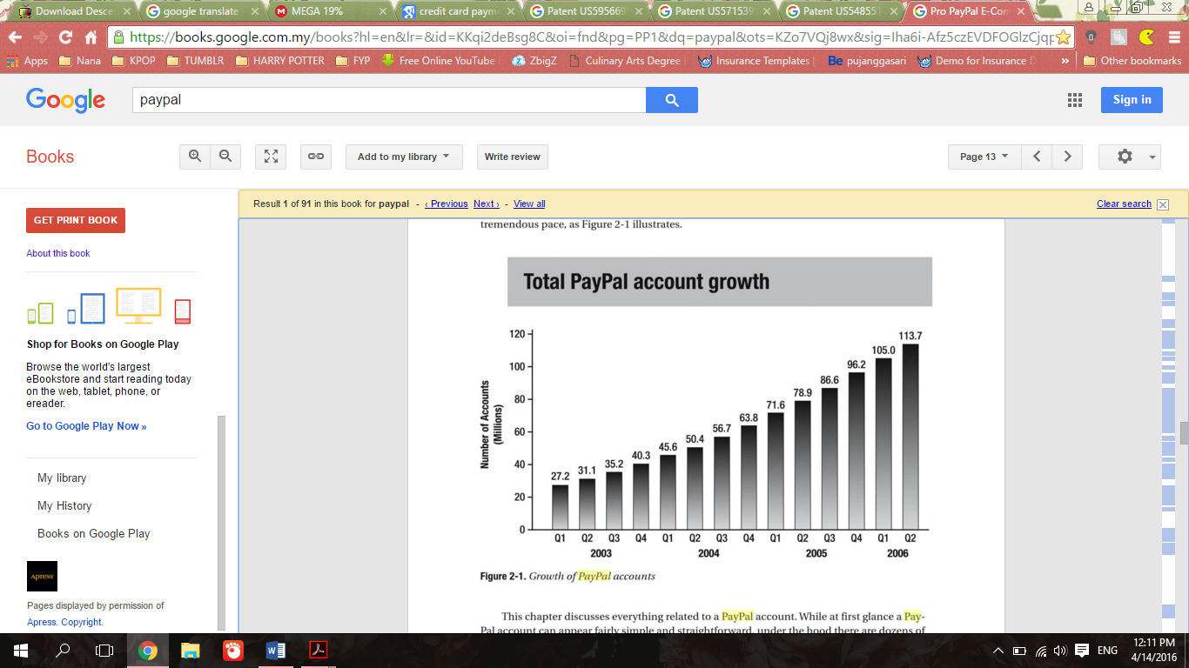

**Figure 2.2** Growth of PayPal Accounts in 2003 – 2006

(Source: Williams, 2007)

Every day, over 100,000 people register for PayPal’s service and every second more than $1,000 goes through the PayPal financial engine, and a large number of individuals and businesses around the world choose PayPal as solution to meet their online payment needs (Williams, 2007). Many people choose PayPal as online payment system due to many reasons. According to Masoud et al. (2013), PayPal is popular because it offers high level of security. PayPal puts their customer’s financial security as their top priority. For example, nobody will be able to see the information of customer’s bank and credit card numbers that are stored by PayPal. The authors also added that the number one reason for its popularity probably because of the ease of registering a PayPal account and receiving payments rather than opening a merchant account with a traditional payment gateway.



**Figure 2.3** Typical NVP Request and Response

(Source: Masoud et al., 2013)

The basic request and response workflow of Name-Value Pair (NVP), which is common to any web application have demonstrate in Figure 2.3 above. PayPal’s NVP API simplify the implementation of payments to test out to your application (Masoud et al., 2013). The request identifies the name or method of the API operation to be performed, PayPal API credentials and operation- specific parameters formatted as name/value pairs. The PayPal API server executes the operation and returns a response containing acknowledgment of success or failure (including any warnings returned if failure), PayPal tracking information specific to the API operation and response-specific information required to fulfill the request.

**2.3.1.1 Sandbox PayPal**

According to Williams (2007), a Sandbox account is used for trial purpose. It is a Personal, Premier or Business account that is created within PayPal’s testing environment. The functions is as same as PayPal account, but have one different which is no real money is used. So, everyone can test their code in Sandbox accounts safely. A Developer Central account must be created before a Sandbox account is created. Fake contact information can be used to create a Sandbox account. An example of Developer Central account with a Business Sandbox account and a Personal Sandbox account is shown in Figure 2.4 below.



**Figure 2.4** A Sample Developer Central Account with two Sandbox Accounts

(Source: Williams, 2007)

According to Williams (2007), PayPal will prompt to add a bank account to the Sandbox account once the Sandbox account is verified and it will generate a fake bank account number to implement for testing, and they are confirmed automatically.

**2.3.2 Credit Card Online Payment**

A credit card is a payment card issued to cardholders to enable them to pay a merchant for goods and services. While online shopping are becoming popular today, cardholders are more worried about the lack of cardholder authentication and card scam in the current online credit card payment (Xiao, Christianson, & Zhang, 2008). Most online shopping sites require customer to input the details of the card including the three digits at the back of the card. Anyone can perform payment illegally if they know the information of credit card (Yan & Chiu, 2007).

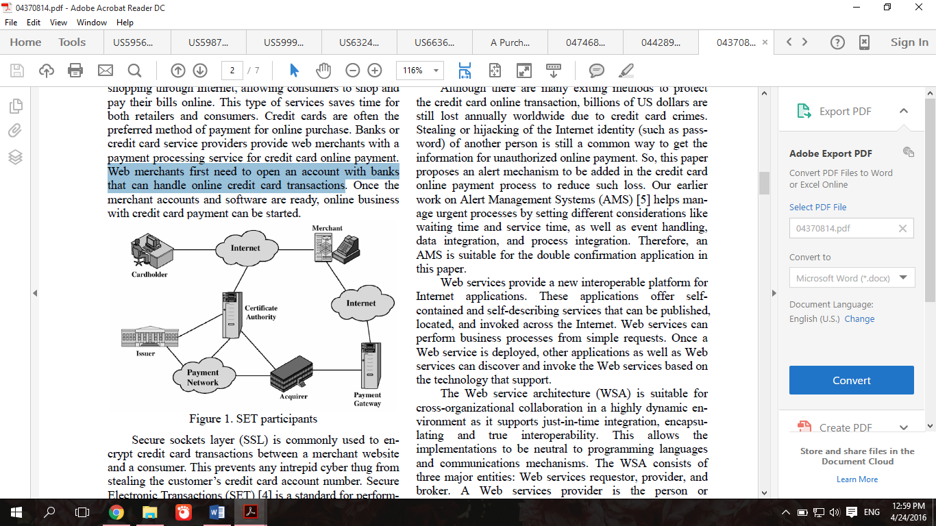

**Figure 2.5** Set Participant in Credit Card Online Payment

(Source: Yan & Chiu, 2007)

According to Yan & Chiu (2007), credit card service providers provide payment processing service to web merchants for credit card online payment as shown in Figure 2.5. First, web merchants have to open a bank account that can handle the transaction of online credit card. Online credit card payment for business can be started once the merchant accounts and software are ready.

Although credit card online payment can save time and convenient to both merchants and customer, it also can increase the chance of credit card information being stolen. So, to prevent that from happened, do not exposed the credit card information to retailers.

**2.3.3 Mobile Payment**

Mobile payment is a payment service performed from or through a mobile device (Wang, 2014). The growing competition among domestic mobile payment apps has increased rapidly since 2012 (Mao & Chen, 2015). According to Wang (2014), mobile payment has become much simple and convenient and gained its popularity in many regions. Many mobile payment systems are applicable on Android and iOS devices. A bank account, a credit or debit card, or a store-issued card, is always required to link to a mobile payment account before a purchase can be made.



**Figure 2.6** Mobile Payment Process

(Source: Wong, 2014)

Figure 2.6 above shows a process of mobile payment. According to Wong (2014), mobile payment process is differs from traditional card payment process because there are two new players introduced which are mobile network operators (MNOs) and mobile payment service providers (MPSPs). MNOs are mobile network carriers who offer direct carrier billing services. MPSPs are the service providers who provide mobile payment services. New business models are also created as new players are introduced. A mobile payment user can now send money to another user within a mobile payment system. The process may involve only cardholders and a mobile payment service provider. There is no merchant, acquirer, card associations, and issuer involved in the process. The mobile payment service provider serves the role as an acquirer.

**2.4 Notification**

Notification is an act of notifying or informing someone about something or event that will happen. Furthermore, notification system is a combination of software and hardware that facilitate delivering a message to a set of recipients.

**2.4.1 Push Notification**

Push notification is an important method to give interesting information to users up-to-date. (Pan et al., 2015). It is used by different service providers to promote or advertise their services to users (Gudla et al., 2015). Push notification is accessible to all type of operating system such as iOS and android. It gave a big impact on business and e-commerce of company. Kumar & Suchi (2015) believed that push notification can attract more customers in their business by tracking the interest area of the customers. It is because push notification is the quick way to alert the user about the activities and updates about the particular business.

**2.4.2 Email Notification**

Today, people communicate with one another in various ways. Electronic mail or email has become a frequent and always favored method of communication (Lewis, 2007). There are a few examples of communication technologies which are telephones, I-pagers, cell phones and email (Kirkpatrick, 2009). Skladman et al. (2002) stated that, users must directly access their e-mail accounts to retrieve e-mail messages in conventional e-mail systems. The authors also highlighted that an e-mail system can operate in conjunction with a notification system to facilitate timely and convenient notification of incoming e-mail messages. An email notification system is a computer-based communication system that can transfer messages to a subscriber and notifying him/her of particular events (Skladman et al., 2002). When a sender send a message via email, the message is sent to the mail server tasked with Mail Transport Agent (MTA) to the recipient's MTA. MTAs communicate with one another using the Simple Mail Transfer Protocol (SMTP).

**2.4.3 SMS Notification**

SMS stands for Short Message Service. It is a basic protocol to send and receive message in a form of text via handheld device. SMS service is a popular application among the all range of people because it is simple, convenient, quick and interactive, ease the communication of person, with cost-effective and user friendly (Fazliza, Yazrina & Muriati, 2011). According to the authors, SMS is favored between mobile phone users because it saves time, energy and money. SMS is a simple push system as a server can reach its client by sending app directed SMS messages (Gudla et al., 2015). In conclusion, SMS is easier to get and read compared to email because it is not requiring internet connection.

**2.5 Market Basket Analysis**

Market Basket Analysis (MBA) is a technique of data meaning that is used for system invention of the relation between one items to another. The possible rate of the relation of associated items provide the new knowledge so it is very helpful for the determiner to take the decision (Nersih, 2015). Gupta & Yadav (2014) stated that Market Basket Analysis (MBA) is also used to increase the sale of a product. We can discover the sale of a particular product and sale of area wisely by the help of this analysis. According to Trnka (2010), Market Basket Analysis (MBA) has the objective of analyzing products, or a group of products, which tend to take place together in buying transactions. It is also can be used to increase the effectiveness of a promotional campaign: items that are related should not put on promotion in the meantime. In conclusion, Market Basket Analysis (MBA) is used to find out the buying habit of the customer.

**2.5.1 Analysis of Association**

Association rule mining is one of important data mining techniques. It helps to find all rules in database that satisfy some minimum support and minimum confidence constraints (Liu, 1998).

1. Support

According to Kotsiantis and Kanellopoulos (2006) support(s) of an association rule is described as the percentage of record that consist of X ∪ Y to the total number of records in the database. Suppose the support of an item is 0.1%, means that only 0.1 percent of the transaction contain purchasing of item. Nengsih (2015) added that support is to link the percentage between the two items and to describe the combination of the item which is fulfill the minimum requirement of support value. Support value of an item and two items is accomplished by using the following formula in Figure 2.7 and Figure 2.8 below.

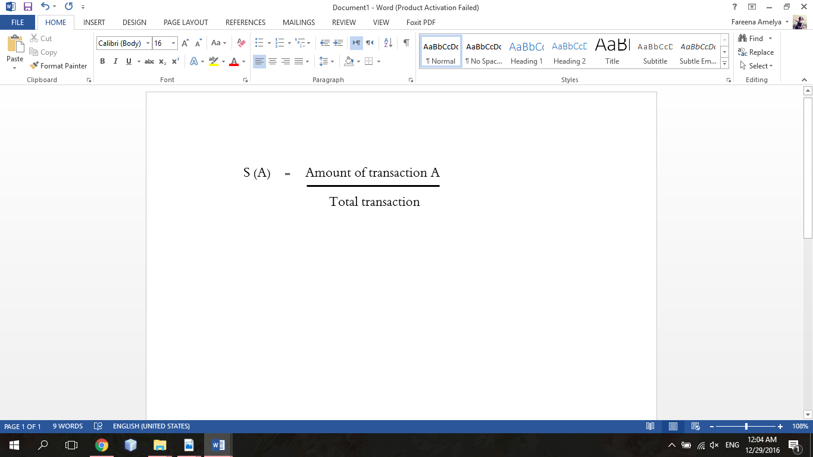

**Figure 2.7** Equation for Support Value of an Item

(Source: Nengsih, 2015)

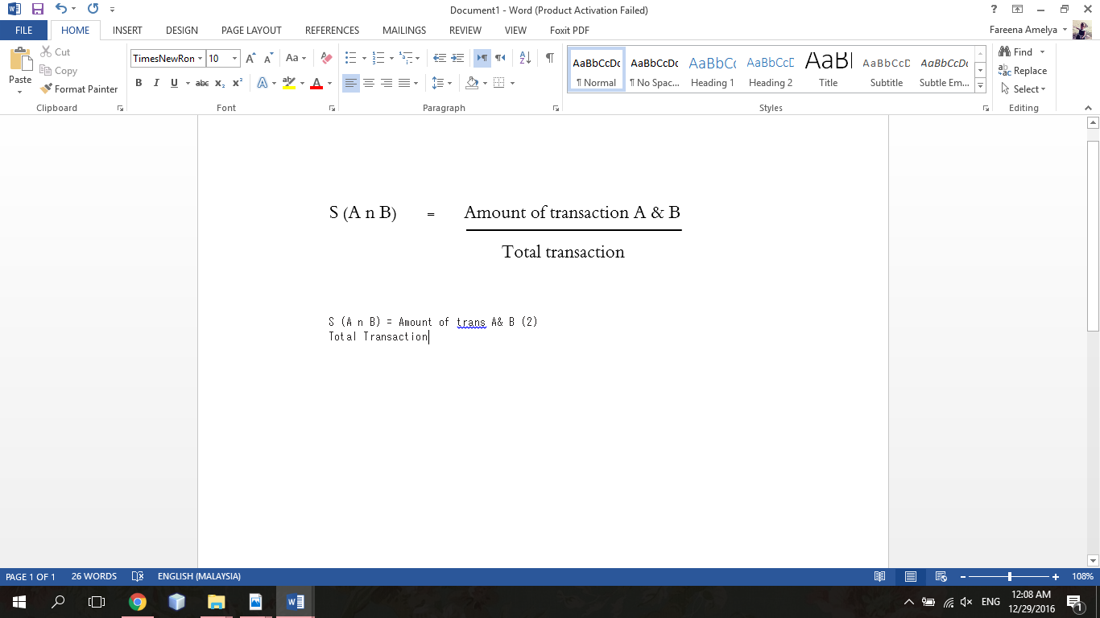

**Figure 2.8** Equation for Support Value of two Items

(Source: Nengsih, 2015)

1. Confidence

Confidence of an association rule is illustrated as the percentage of the number of transactions that contain X ∪ Y to the total number of records that contain X (Kotsiantis and Kanellopoulos, 2006). Confidence is a measure of strength of the association rules, suppose the confidence of the association rule X⇒Y is 80%, it means that 80% of the transactions that contain X also contain Y together. Nengsih (2015) stated that the frequencies of the item Y appear in the transaction which contains X. After all of system of high frequency found, then rules need to be found.

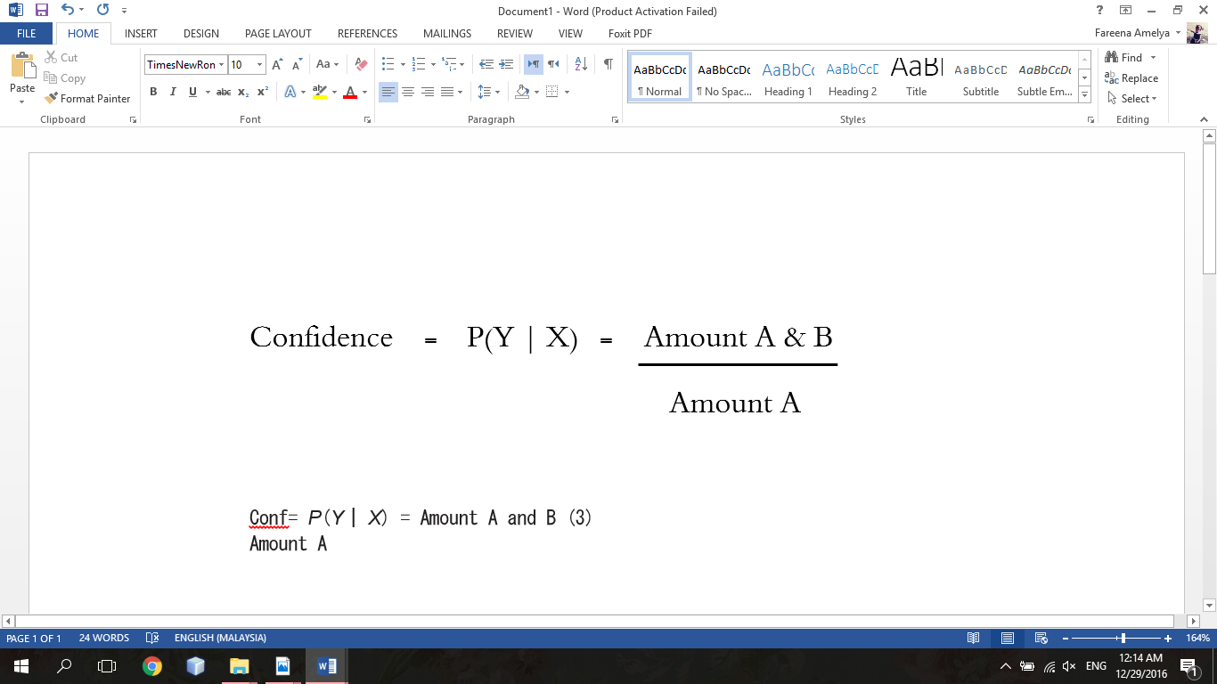

**Figure 2.9** Equation for Confidence Measurement

(Source: Nengsih, 2015)

**2.6 Related Works**

There are many culinary class management system that are available around the world nowadays. Some of the system, like Southern Season Cooking School can be compared to Pusat Latihan Perhotelan (PLP) Azam Pandan, Melaka.

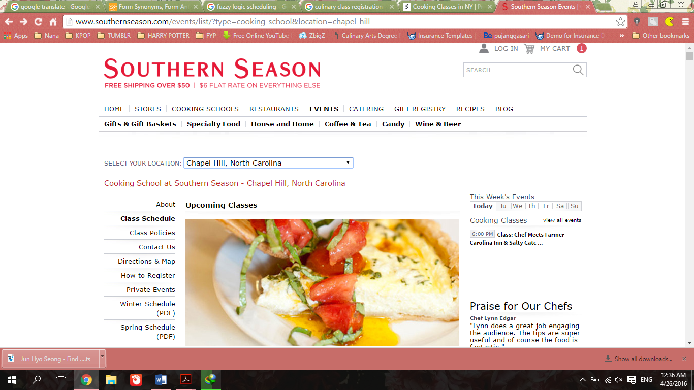

**Figure 2.10** Southern Season Cooking School homepage

(Source: Southern Season Cooking School, 2017)

Southern Season cooking school is located at Chapel Hill, North Carolina and Charleston, South Carolina. It is a culinary class system that can be accessed by any user. Based on the Figure 2.10 above, it shows that this system is providing an online registration for anyone who want to enter the cooking class. This system also provide a class schedule of particular menu. Anyone who wish to enter the class need to check the class schedule first and click register on the class they want to attend. The payment can be made online after they registered. Once registered, the user may change the quantity of seats they wish to purchase in their shopping cart. Compared to Pusat Latihan Perhotelan (PLP) Azam Pandan, Melaka, this system does not provide Market Basket Analysis to determine the buying behavior of the customer.

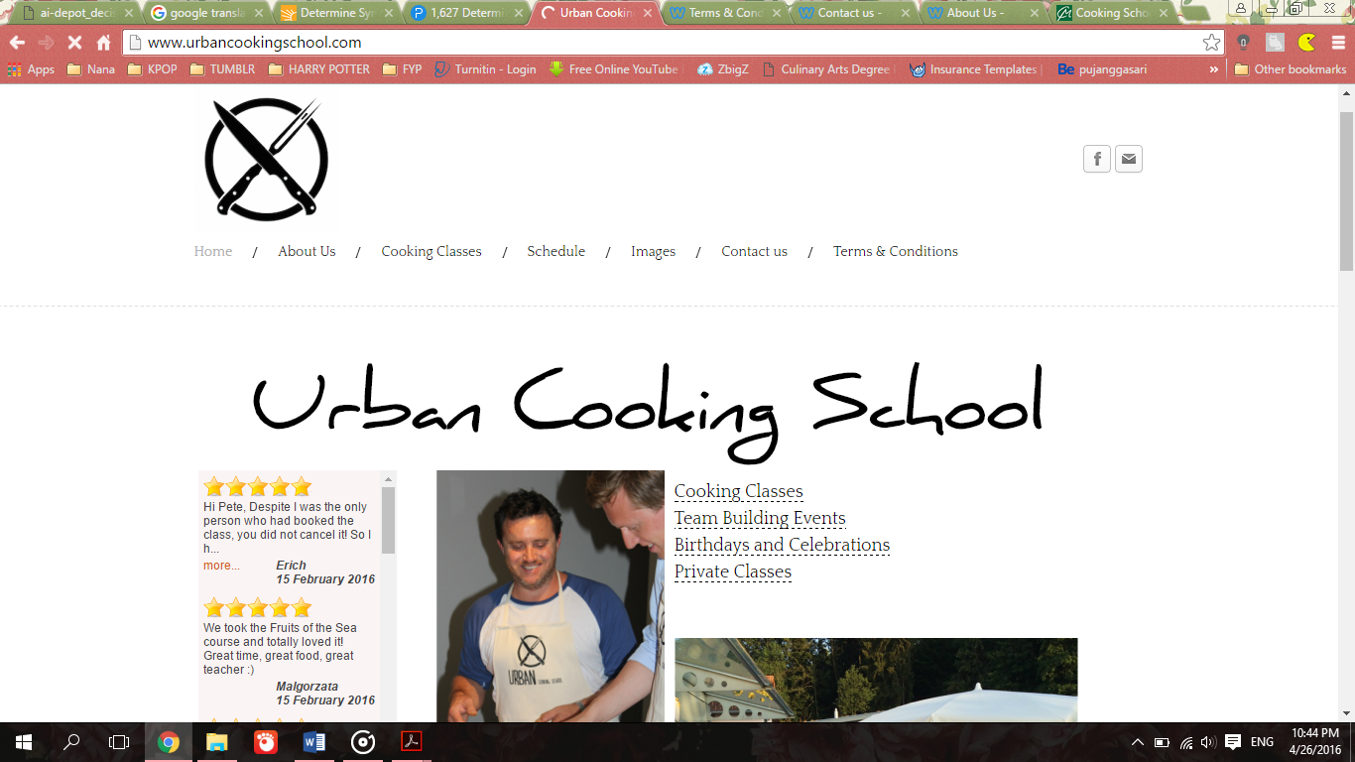

**Figure 2.11** Urban Cooking School homepage

(Source: Urban Cooking School, 2015)

Urban cooking school is located at Switzerland. It is offering a classes based around the seasons, produce available and different cultures. This system provide an online registration for anyone who want to join the class. User have to book the class they want to enter based on the schedule given. The difference of this system with Pusat Latihan Perhotelan (PLP) Azam Pandan, Melaka system is user have to made payment two weeks before attend a scheduled class because they do not provide any online payment.

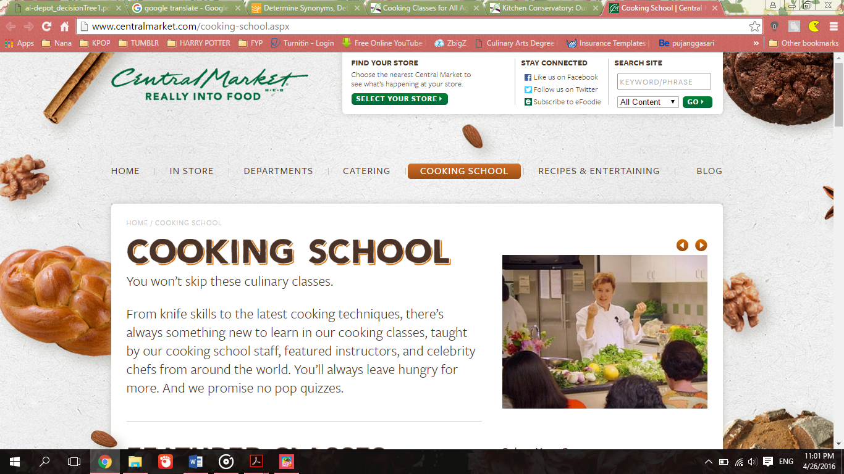

**Figure 2.12** Central Market Cooking School homepage

(Source: Central Market Cooking School, 2001)

Central Market cooking school has 7 branch which are at Austin North Lamar, Dallas Lovers, Fort Worth, Houston, Plano, San Antonio and Southlake. Based on the Figure 2.12 above, it shows that this system provide not only registration but recipes finding and also blog about the event that happened. The system provide information of the class that will be held including date, time and place so the user just need to register the particular class. The system also provide an online payment just like Pusat Latihan Perhotelan (PLP) Azam Pandan Culinary Class Management System. This website stated that it uses industry standard SSL (secure socket layer) encryption to protect the information of credit card so anyone can feel safe making payments on the site.

**2.7 Summary**

In conclusion, this chapter discussed about literature review on each topics that are being focused in this project including the research studies on Pusat Latihan Perhotelan (PLP) Azam Pandan, Melaka.

**CHAPTER 3**

**METHODOLOGY**

Methodology is important because it determine and specify which method to be applied to achieve the aim and objective of this project. This chapter discussed in details about methodology that is used and implemented through the development process of this project. There are a few phases in methodology which are information gathering phase, requirement analysis phase, design phase, development phase and testing phase.

**3.1 Project Methodology**

Methodology is a technique used to collect data and information for the business decisions making purpose. It is a complete explanation of process and methods to achieve the objective of the project. Modified Waterfall model has been chosen to be used in development of Pusat Latihan Perhotelan (PLP) Azam Pandan Melaka Culinary Class Management System. This method has the same stages as the Traditional Waterfall model. The quantity of issues with the Traditional Waterfall model was making it seem redundant. To enhance it further, Modified Waterfall model appeared. The difference in the model is that the stages have some overlap, implying that there are numerous tasks that happen simultaneously. This overlap allow for some back tracking to absorb changes to requirements based on what is learned during the development stage. In a mean time, making changes to the basic design is also potential, as there are a several phases active at one point of time. If there are any mistakes due to changes made, correcting them is also possible. Modified Waterfall is consisting of a few phases which are planning, analysis, design, development and testing.

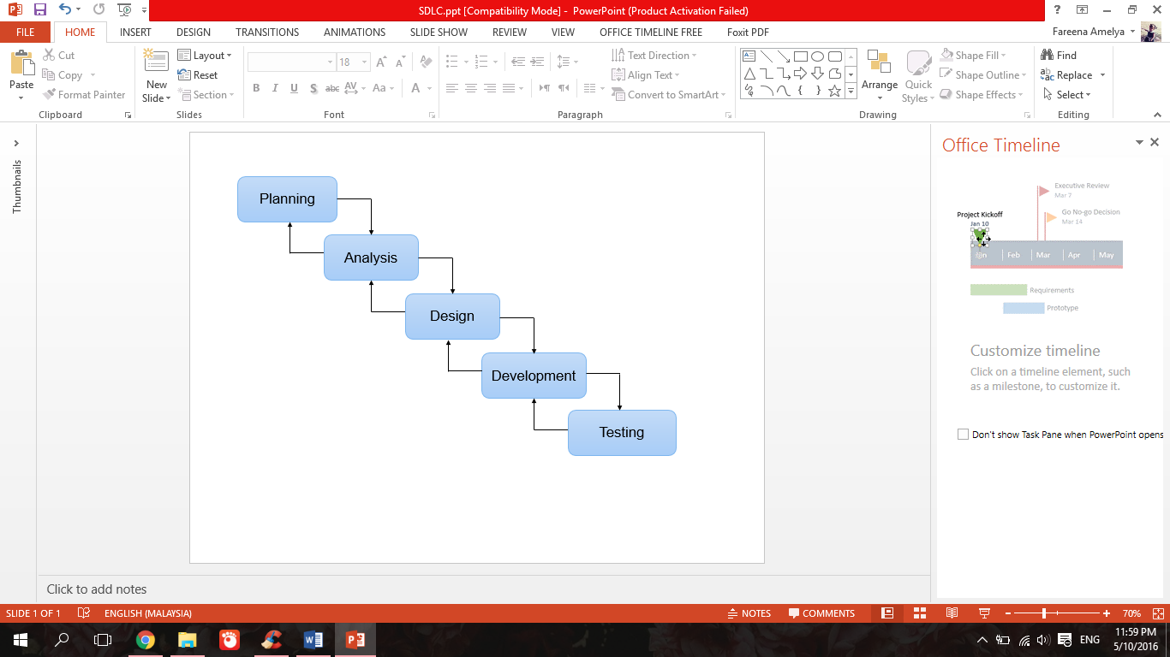

**Figure 3.**1 Modified Waterfall Model

**3.2 Project Formulation Framework**

The details of the flow for each phase discussed in project formulation framework as shown in Table 3.1 below.

**Table 3.1** Illustration of Project Framework

|  |  |  |
| --- | --- | --- |
| Phase Name | Activities | Outcome |
| Planning | Conduct an interview with the stakeholder, Manager of Pusat Latihan Perhotelan (PLP) Azam Pandan Melaka, Mrs. Marzaroten binti Yahya about the current problems | SOP of Pusat Latihan Perhotelan (PLP) Azam Pandan Melaka. |
| Analysis | 1. Identify problem statement 2. Identify project objective 3. Identify project significance 4. Identify project scope | 1. Hardware requirement 2. Software requirement |
| Design | 1. Design Use Case Diagram 2. Design Flowchart Diagram 3. Design ERD Diagram 4. Design System Architecture Diagram 5. Design User Interface Diagram 6. Design Algorithm | Project development flow |
| Development | 1. Install software 2. Coding development | Programming |
| Testing | 1. Functionality Testing | Result |

**3.3 Planning Phase**

Planning is the first phase through development of Pusat Latihan Perhotelan (PLP) Azam Pandan, Melaka Culinary Class Management System. The purpose of the Planning Phase is to plan all the project processes and activities required to ensure project success and to create a comprehensive set of plans. Interview with the manager of Pusat Latihan Perhotelan (PLP) Azam Pandan, Melaka, Mrs. Marzaroten binti Yahya was conducted on 16 March 2016 to know the current problems faced by the company. The set of questions is included in Appendix A.

There are some problems that has been issued based on the interview conducted. The staff in Pusat Latihan Perhotelan (PLP) Azam Pandan, Melaka is having difficulty to manage the registration fees of the culinary class. The manual system is not efficient because student need to pay the registration fees at least one week by coming to the office. Besides that, the staff also having difficulty to determine the customers booking preferences. The staff want to monitor the sales of company based on the class which is on high demand.

Therefore, Pusat Latihan Perhotelan (PLP) Azam Pandan, Melaka Culinary Class Management System is developed to overcome those problems. This system is providing an online web based system that manage a students in Pusat Latihan Perhotelan (PLP) Azam Pandan, Melaka.

**3.4 Analysis Phase**

After the information is gathered through interview, the analysis phase is conducted to investigate the problems based on the interview. The hardware and software requirement had decided in order to develop and make the analysis about the system development.

**Table 3.2** Hardware used for Pusat Latihan Perhotelan (PLP) Azam Pandan, Melaka Culinary Class Management System

|  |  |
| --- | --- |
| Features | Specifications |
| Device | Laptop |
| RAM | 4GB |
| Storage | 500GB (Internal hard disk) |
| Processor | Intel Core i5-6200U 2.3GHz |
| Operating System | Windows 10 |

**Table 3.3** Software used for Pusat Latihan Perhotelan (PLP) Azam Pandan, Melaka Culinary Class Management System

|  |  |
| --- | --- |
| Features | Specifications |
| Development tools | PHP server |
| Operating System | 64 bit Windows 10 |
| Framework | CodeIgniter |

**3.5 Design Phase**

The third phase in this project is a design phase. This phase is to define the overall system of Pusat Latihan Perhotelan (PLP) Azam Pandan, Melaka Culinary Class Management System. The use case diagram, flowchart diagram, entity relationship diagram, system architecture and user interface is explained in details in this phase. These diagrams is important to help developer to interpret the flow of the web based system.

**3.5.1 Use Case Diagram**

A use case diagram is a representation of user’s interaction in a system. It consists of actors, use cases and their relationship. Figure 3.2 below illustrated the use case diagram for this project.

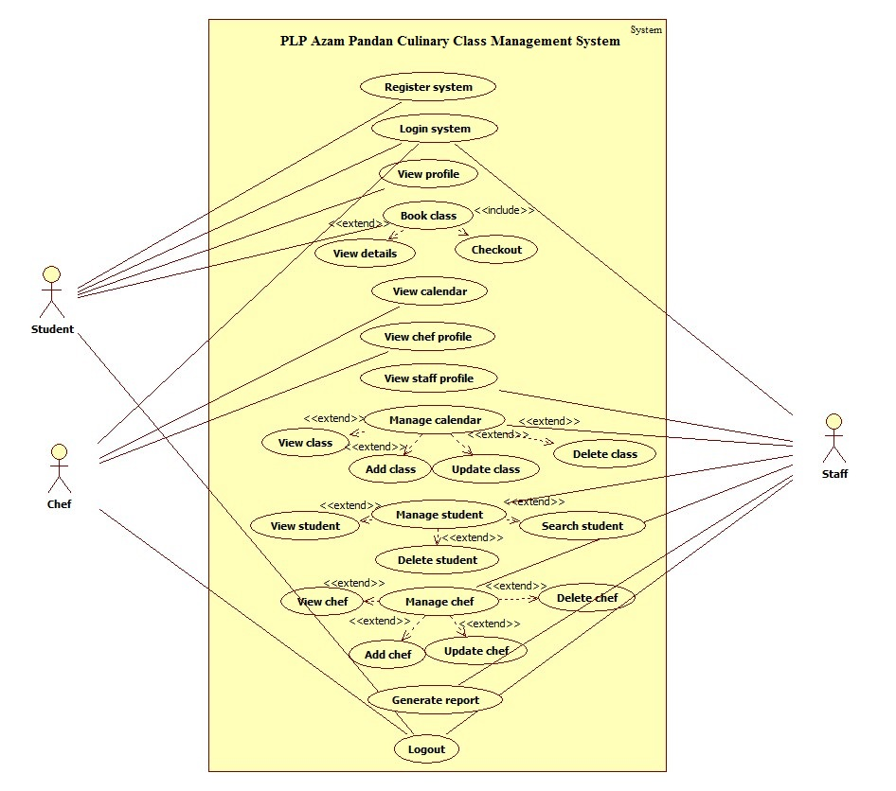

**Figure 3.2** Use Case Diagram for Pusat Latihan Perhotelan (PLP) Azam Pandan, Melaka Culinary Class Management System.

There are three types of user in Pusat Latihan Perhotelan (PLP) Azam Pandan, Melaka Culinary Class Management System who are student, chef and staff. Firstly, every user are required to login to the system. Student who doesn’t have an account has to register to the system first. Then, student will be able to view their profile right after they logged in to the system. They can book classes based on the details that provide in the web based system and pay the fees online. They have two options to pay the fees whether to pay by using PayPal or upload the receipt after they made the payment. Chef will be able to view the calendar of Pusat Latihan Perhotelan (PLP) Azam Pandan, Melaka Culinary Class and view their own profile. Staff will be able to manage class, manage student and manage chef. In manage class, staff can view class, add class, update class and delete class in the system. In manage chef, staff also can view chef, add chef, update chef and delete chef. In manage student, staff can view student, delete student and search student based on their name. Next, the staff also can view the generated report. There are two types of report which is the statistics of each class that is booked by student and a Market Basket Analysis (MBA) report which is the report that shows a combination of class that is booked by student. Lastly, every user can logout from the system.

**3.5.2 Flowchart Diagram**

A flowchart is a representation of sequence of steps and decisions needed to perform a process. The steps are represented by a diagram shape connected with arrows. There are three types of flowchart diagram created for this project which are process for Student, Chef and Staff of Pusat Latihan Perhotelan (PLP) Azam Pandan, Melaka.

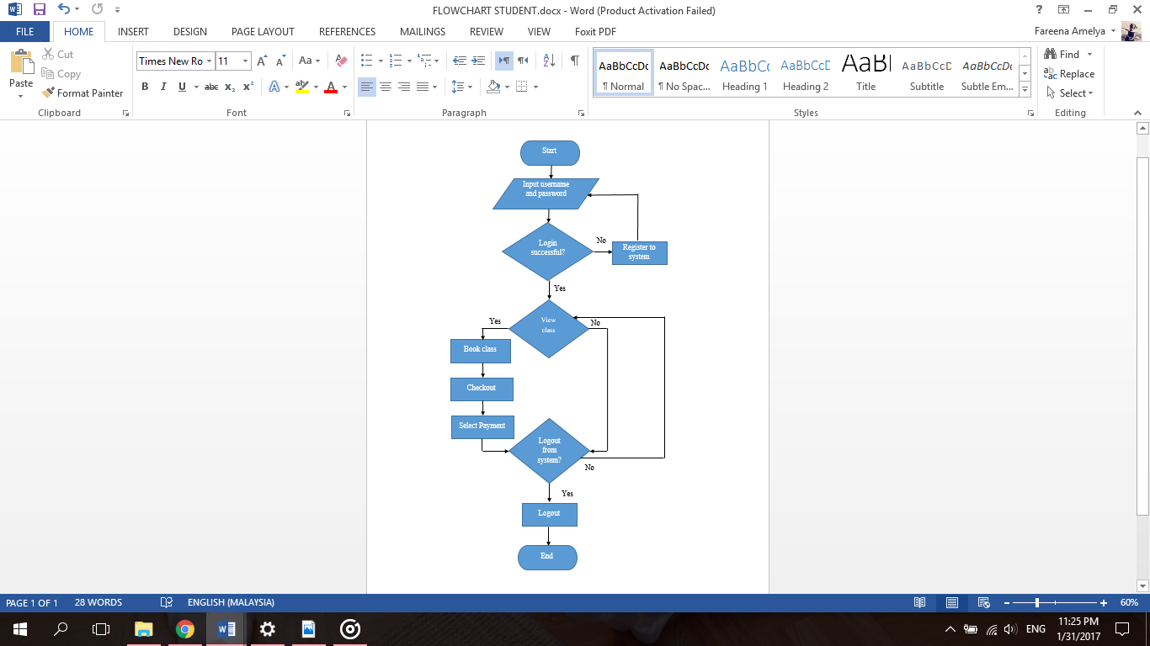

**Figure 3.3** Flowchart Diagram for Student of Pusat Latihan Perhotelan (PLP) Azam Pandan, Melaka

Figure 3.3 above shows the flowchart diagram for student of Pusat Latihan Perhotelan (PLP) Azam Pandan, Melaka. The student who want to use the system have to register an account first. After that, they can access the system by login to the system. If the student fail to login to the system, he or she has to try login again to the system. After he or she has successfully login, the student can view their profile. They can view all of the class that is available including the details and they can made booking. The student can book more than one class. The payment of the fees must be made online. They have two different options on how to made payment which are by using PayPal or uploading the receipt of the payment that had been made. Lastly, they can logout any time from the system.

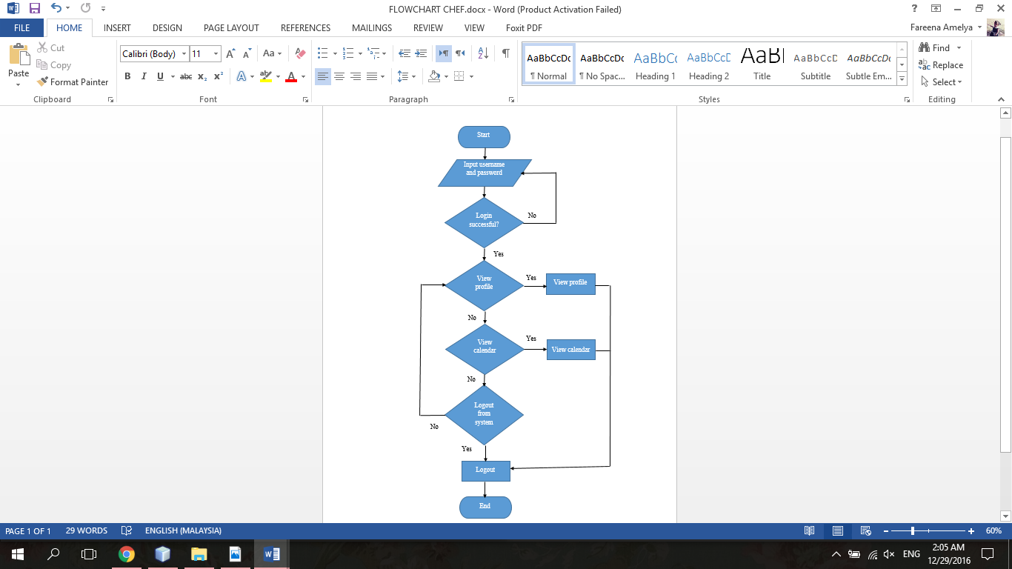

**Figure 3.4** Flowchart Diagram for Chef of Pusat Latihan Perhotelan (PLP) Azam Pandan, Melaka

The flow of process for chef to access Pusat Latihan Perhotelan (PLP) Azam Pandan, Melaka Culinary Class Management System as demonstrated in Figure 3.4 above is quite similar with the flowchart of student in Figure 3.3. Chef also required to login to gain access to the system. Chef can view their profile and calendar that contain details including date and time of the class. Lastly, they also can logout any time from the system.

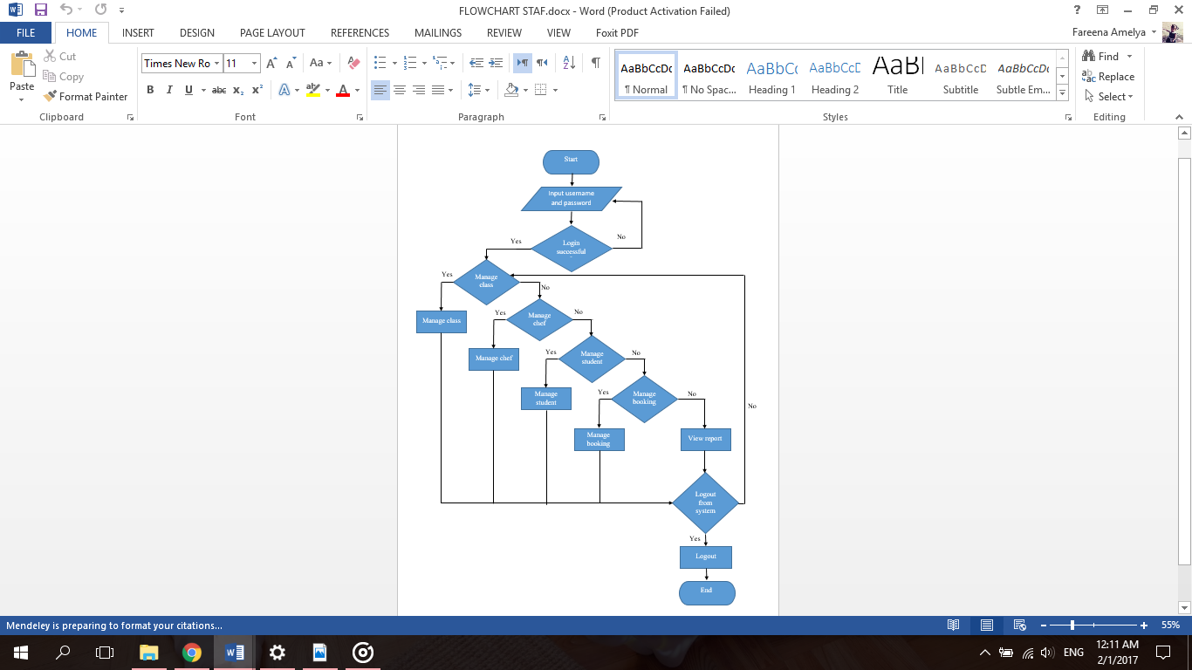

**Figure 3.5** Flowchart Diagram for Staff of Pusat Latihan Perhotelan (PLP) Azam Pandan, Melaka

The staff of Pusat Latihan Perhotelan (PLP) Azam Pandan, Melaka also required to login to enter the system. The staff will be able to manage class, manage chef, manage student and manage booking. The staff can view the generated report. Lastly, they also can logout any time from the system.



**Figure 3.6** Flowchart Diagram for Staff (Manage class) of Pusat Latihan Perhotelan (PLP) Azam Pandan, Melaka

The staff of Pusat Latihan Perhotelan (PLP) Azam Pandan, Melaka can manage class by adding new class, edit existing class, delete class and view all classes.

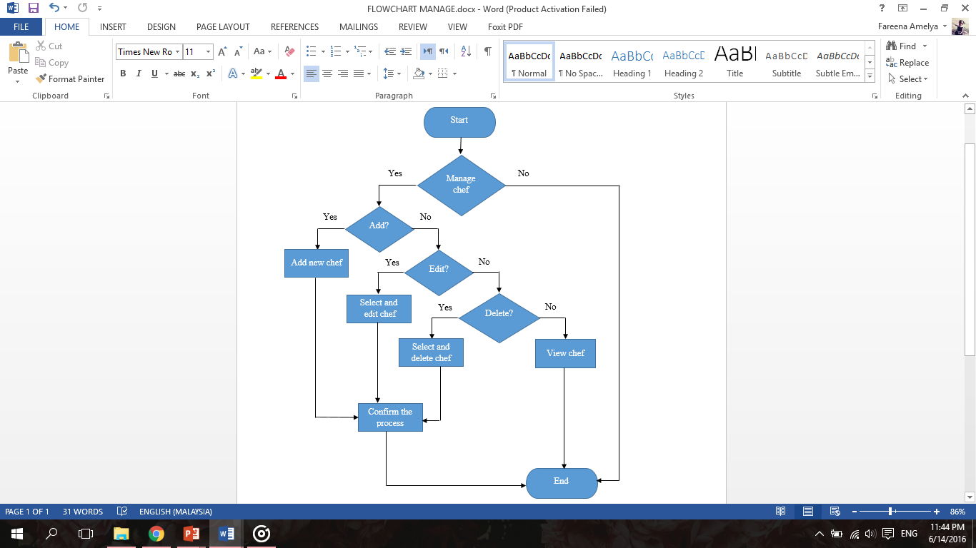

**Figure 3.7** Flowchart Diagram for Staff (Manage chef) of Pusat Latihan Perhotelan (PLP) Azam Pandan, Melaka

The flowchart diagram for staff to manage chef as showed in Figure 3.7 is quite similar with the flowchart diagram for staff to manage class in Figure 3.6. The staff of Pusat Latihan Perhotelan (PLP) Azam Pandan, Melaka can manage chef by adding new chef, edit chef profile, delete chef and view all chef.

**3.5.3 Entity Relationship Diagram (ERD)**

Entity Relationship Diagram (ERD) is a representation of an information system that shows the relationship of entity sets stored in database. To simplify, ERD illustrate the logical structure of databases. Figure 3.8 below shows the Entity Relationship Diagram (ERD) of Pusat Latihan Perhotelan (PLP) Azam Pandan, Melaka Culinary Class Management System.



**Figure 3.8** Entity Relationship Diagram of Pusat Latihan Perhotelan (PLP) Azam Pandan, Melaka Culinary Class Management System

**3.5.4 System Architecture Diagram**

A system architecture is the conceptual model that defines the structure, behavior, and more views of a system. The system architecture diagram for Pusat Latihan Perhotelan (PLP) Azam Pandan, Melaka Culinary Class Management System consist of application server, database server, client and internet as shown in Figure 3.9 below.

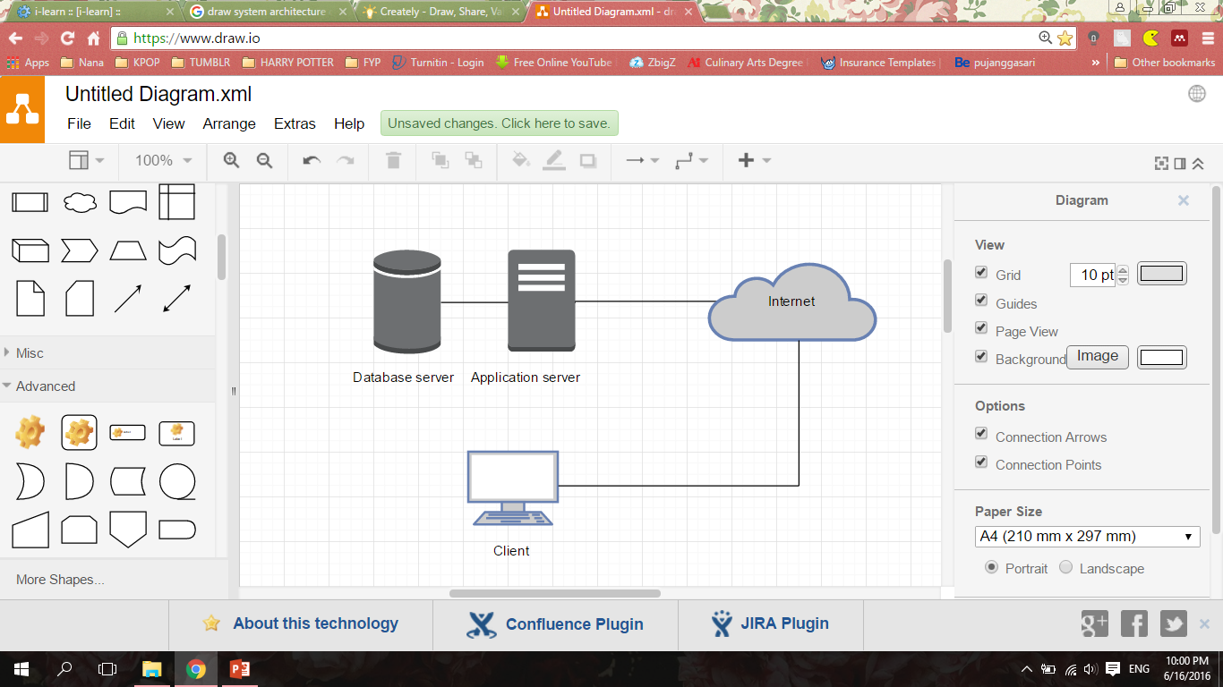

**Figure 3.9** System Architecture Diagram for Pusat Latihan Perhotelan (PLP) Azam Pandan, Melaka Culinary Class Management System

**3.5.5 User Interface**

User Interface Design focuses on anticipating what users might need to do and ensuring the interface has the elements such as easy to understand and access.

The homepage of Pusat Latihan Perhotelan (PLP) Azam Pandan, Melaka Culinary Class Management System contains only background and objectives of the company, list category of menus that offered, the chef background and also login and register page. The company logo are required because it is the icon that symbolically represents the company. If the user doesn’t have an account, they can register into the system by clicking a register button. They are required to fill in the form of their details such as name, email, password, contact number and home address. Meanwhile, the login page is used for registered member to access the system.

**3.5.5.1 Student Interface**

If they are successful login as student, they can view and update their profile. Next, student can view all the details of class that are available. They also can book the class that they like. After they confirmed their booking, they can choose whether to make payment by PayPal or uploading receipt if they are using cash deposit machine. They can view their status of the booking in booking history page.

**3.5.5.2 Chef Interface**

Chef also can view and update their profile. After that, they will be able to see the class timetable in form of calendar. They can view the details of the class including class name, date, time, instructor and location of the class.

**3.5.5.3 Staff Interface**

The staff will be able to manage chef, manage student, manage class and manage booking of class that is booked by the student of Pusat Latihan Perhotelan (PLP) Azam Pandan, Melaka. They can perform a function such as insert, delete, update and view in manage chef, manage student and manage class as been described in Use Case Diagram. In manage booking, the staff will be able to accept or decline the booking status of student. They also can view the generated report of Market Basket Analysis (MBA) to know the customer booking class preferences.

**3.6 Development Phase**

The next phase after design phase is development phase. In this phase, all the software will be installed and coding will started to develop. Besides, this phase also involve the technique that will applied and implemented in order to develop this system. The PHP framework that will be used in this system is CodeIgniter. It is a simple framework for web sites and web applications development. In addition, CodeIgniter helps developer in saving time, making site more robust and achieve more sophisticated coding (Upton, 2007).

Market Basket Analysis (MBA) will be used to generate a report for staff in Pusat Latihan Perhotelan (PLP) Azam Pandan. For payment technique, Sandbox for PayPal will be apply in this project that will manage the online payment for this system.

**3.7 Testing Phase**

Testing is the last phase in Modified Waterfall model. This phase is important to test the system and check if any problems happen in the system. In addition, the testing must be tested and evaluated by an expert. In this phase, the functionality testing has been tested.

**3.8 Summary**

Thus, this chapter explained every phases in methodology framework that will be applied in this project development. Moreover, how the information was gathered, where the information was applied and how the information was used is explained in detail in methodology in order to understand and complete this research.

**CHAPTER 4**

**RESULTS AND FINDINGS**

This chapter will discussed the results and findings from Pusat Latihan Perhotelan (PLP) Azam Pandan Culinary Class Management System web based application. The results and findings are obtained after the functionality testing is conducted. In this chapter, all the results from the functionality testing are recorded and will be reviewed.

**4.1 Results**

The reviews of each results from Pusat Latihan Perhotelan (PLP) Azam Pandan Culinary Class Management System:

**4.1.1 Login System**

Figure 4.1 shows the interface for user to login into the system. The interface was divided into two sides. On the right side of the page, there is a button for user to register an account and will redirect the user to registration form page. While on the left side of the page, there is a form for user to login. The user has to choose to login as whom by clicking the other choices of login option.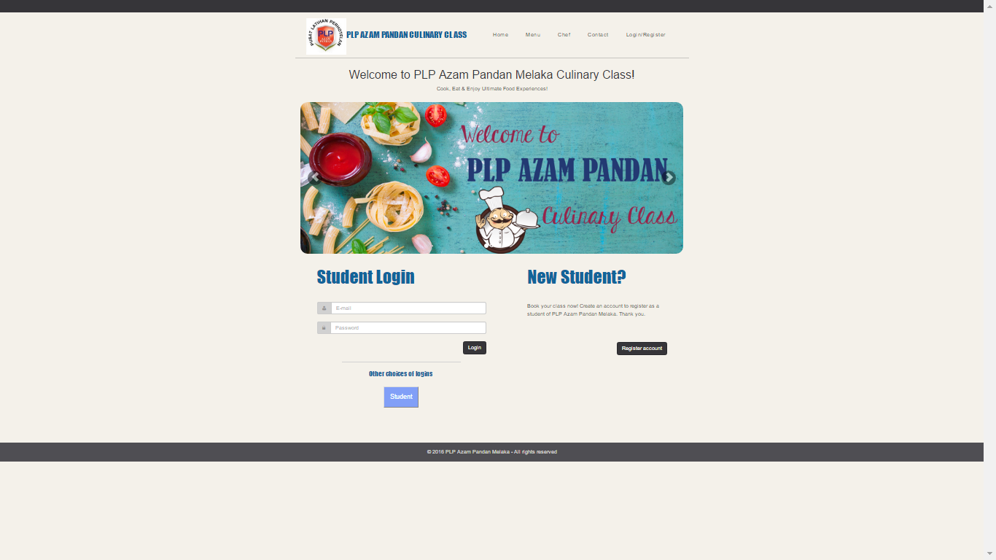

**Figure 4.1** Login Interface

**4.1.2 Register System**

Figure 4.2 shows the interface for student registration. On the registration form, the user required to fill in their details such as the first and last name, email address, password, IC number, address, age, birthday, phone number and gender to create a new account to become a student of Pusat Latihan Perhotelan (PLP) Azam Pandan.

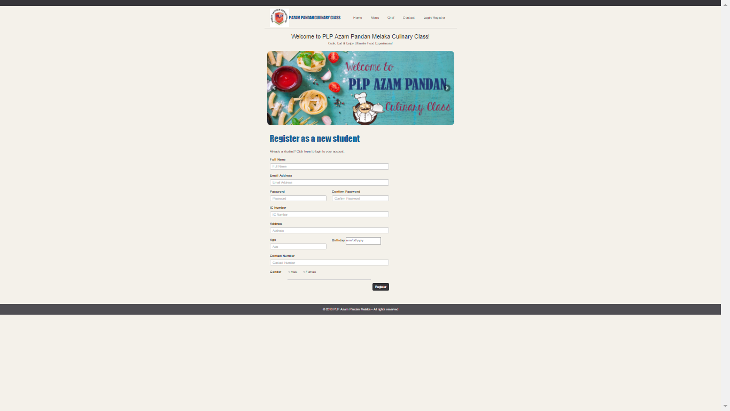

**Figure 4.2** User Registration Interface

**4.1.3 Booking Class Management Interface**

Figure 4.3 below shows the interface for student to view the list of the class that are available. There are the details of each class including the class name, class category, instructor, date and time of the class, description and the fees of class. The right side of the table include action and student can click the button ‘book now’ to insert to the cart.

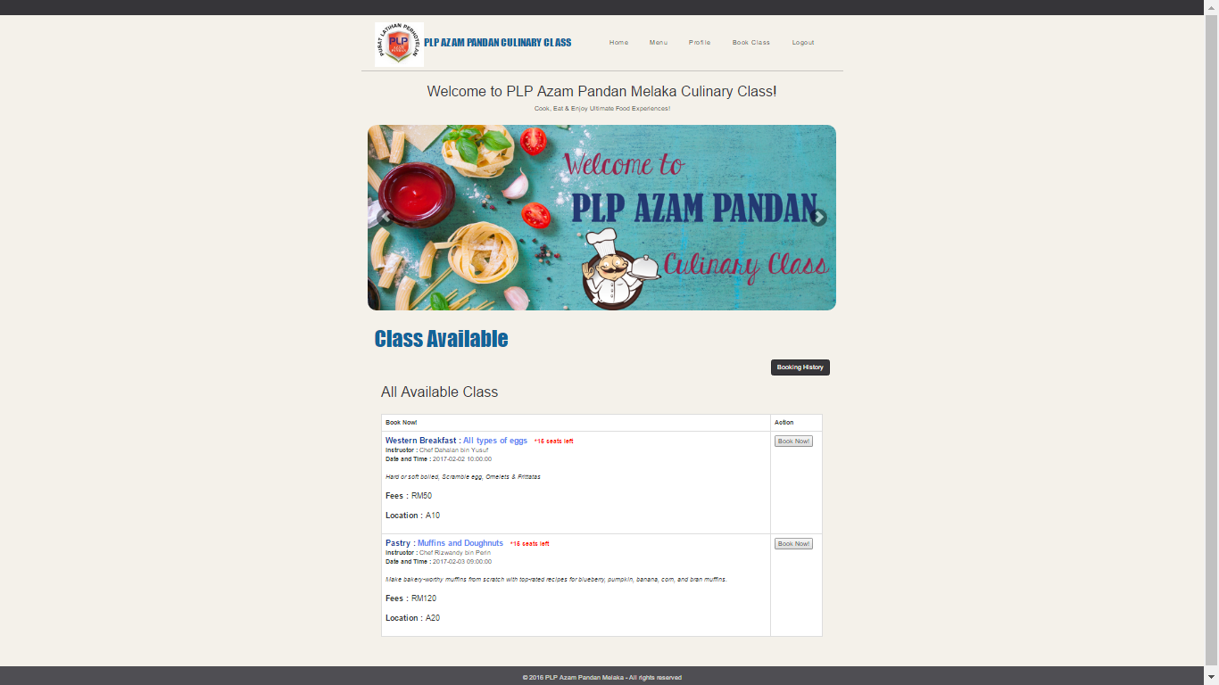

**Figure 4.3** View Class Details Interface

After the student clicked the book button, the interface will display the class name and category and total of fees in cart as shown in the Figure 4.4 below. Student can clear the booking if they want to clear the cart or click place booking button if they want to continue booking another class.

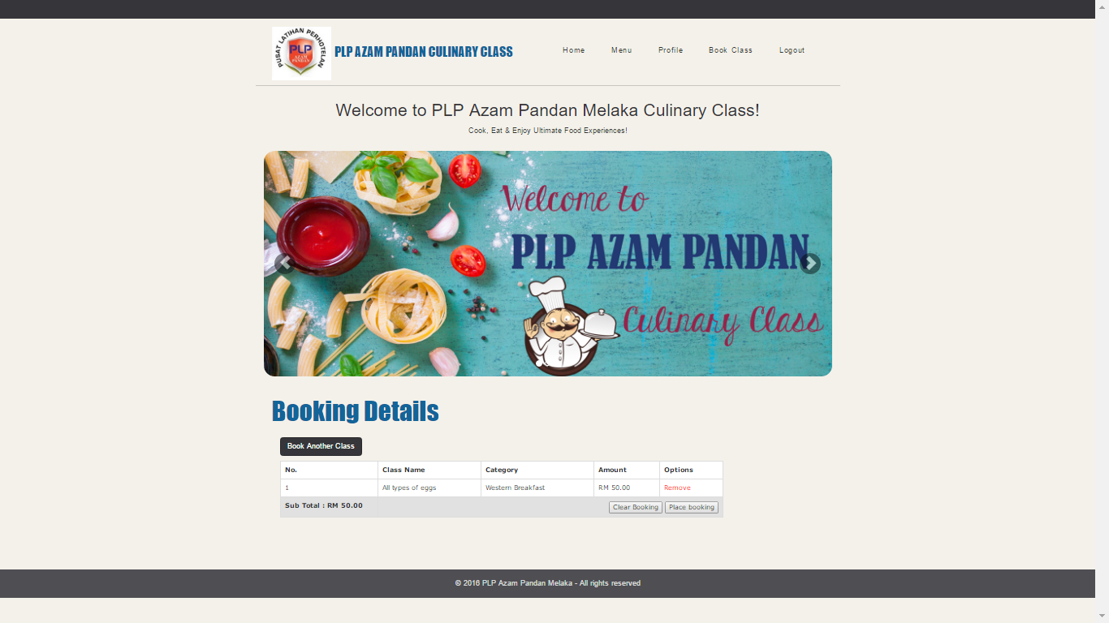

**Figure 4.4** Booking Details Interface

Student can book more than one class by clicking book another class button. If the student choose to place booking, the page will directed user to booking information page. The booking information will show the details of the student and total fees as shown in Figure 4.5 below.

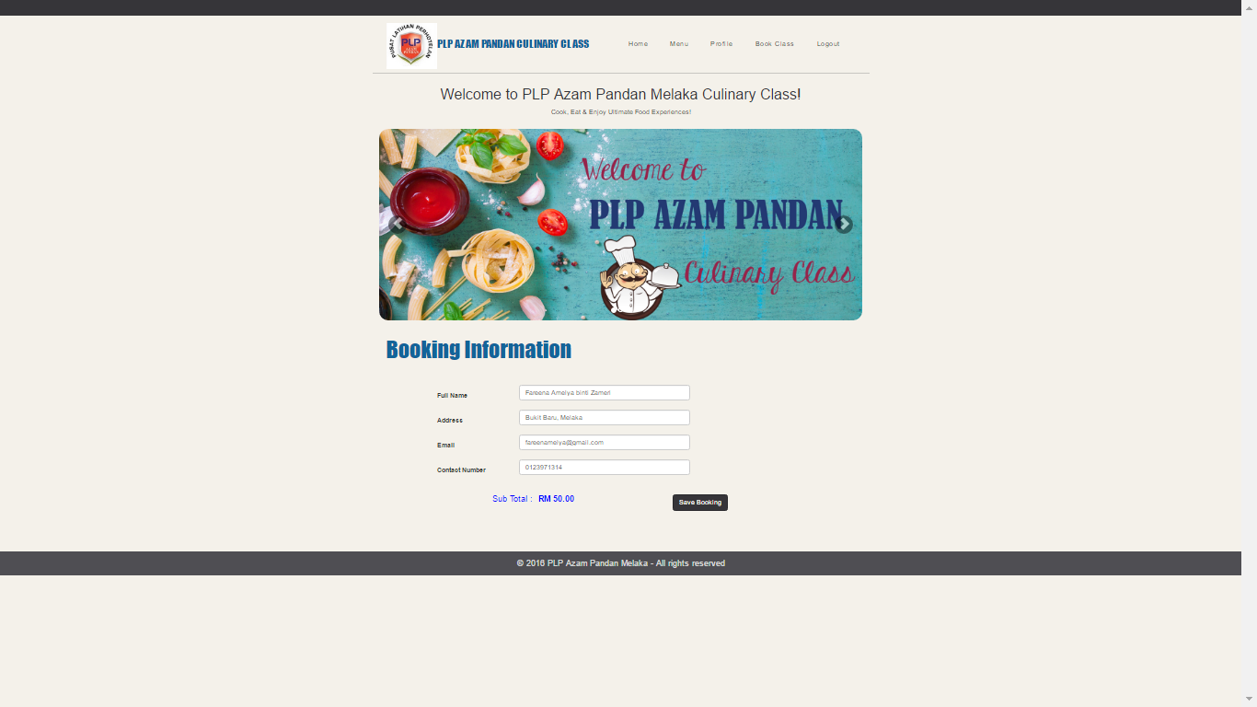

**Figure 4.5** Booking Information Interface

After the student click the save booking button, it will redirect user to payment page. This page also contains booking history button for student to check their list and status of booking. Student can choose to pay the fees by using PayPal or upload the receipt after they bank in the payment as shown in Figure 4.6.

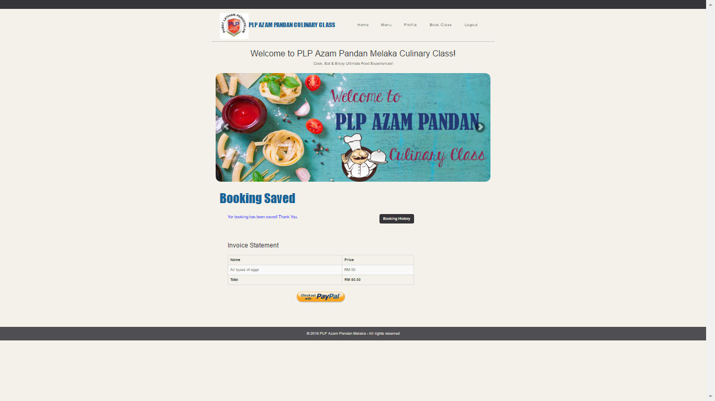

**Figure 4.6** Booking Saved Interface

**4.1.4 Payment Management Interface**

If the student choose to pay the fees by using PayPal, the page is redirected as shown in Figure 4.7 below. The student is required to access their PayPal account to purchase the class.

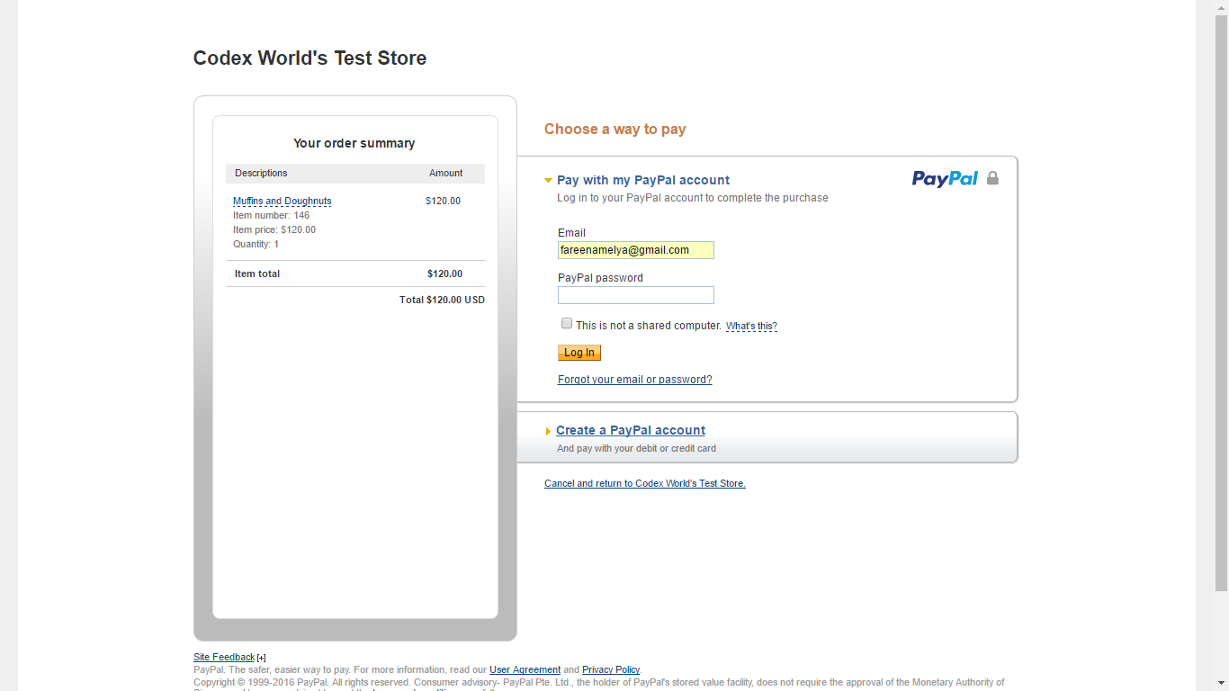

**Figure 4.7** PayPal Payment Gateway Interface

Figure 4.8 and 4.9 below shows the interface if the student want to upload the receipt of the payment. They also can view their booking status whether it is accepted or declined by the staff.

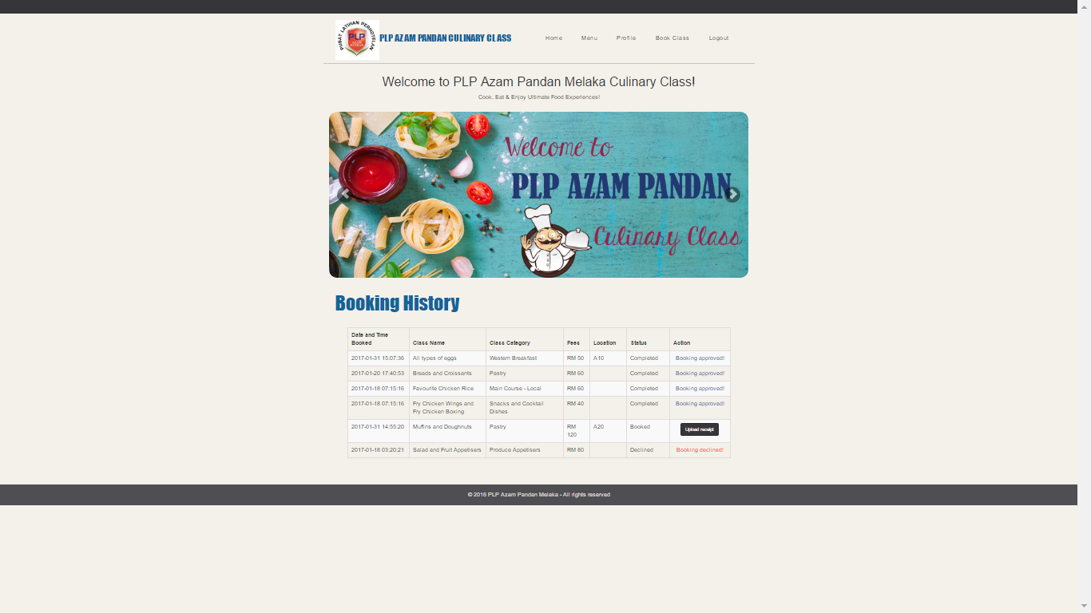

**Figure 4.8** Booking History Interface

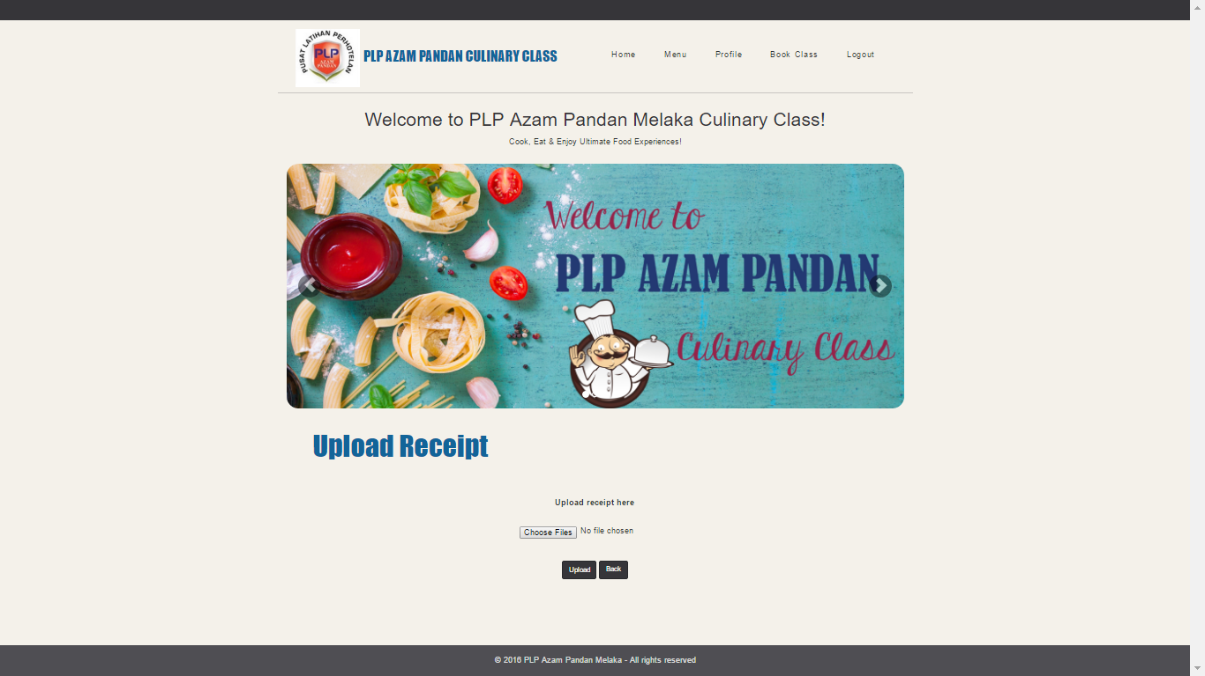

**Figure 4.9** Upload Receipt Interface

**4.1.5 Student Management Interface**

Figure 4.10 below shows the interface for staff to view all the students’ details. The details of the student is displayed in a table form that contains name, email address, age, IC number and contact number.

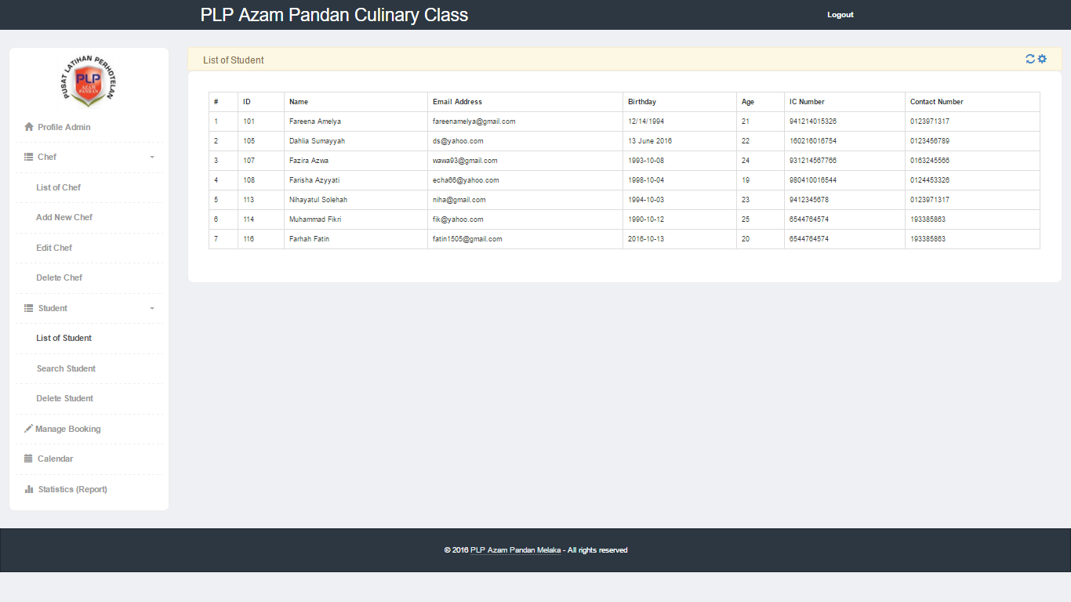

**Figure 4.10** List of Student Interface

As shown in Figure 4.11 below, it is the interface for staff to search the details of the students by input their name. The result contains the student name, email address and contact number.

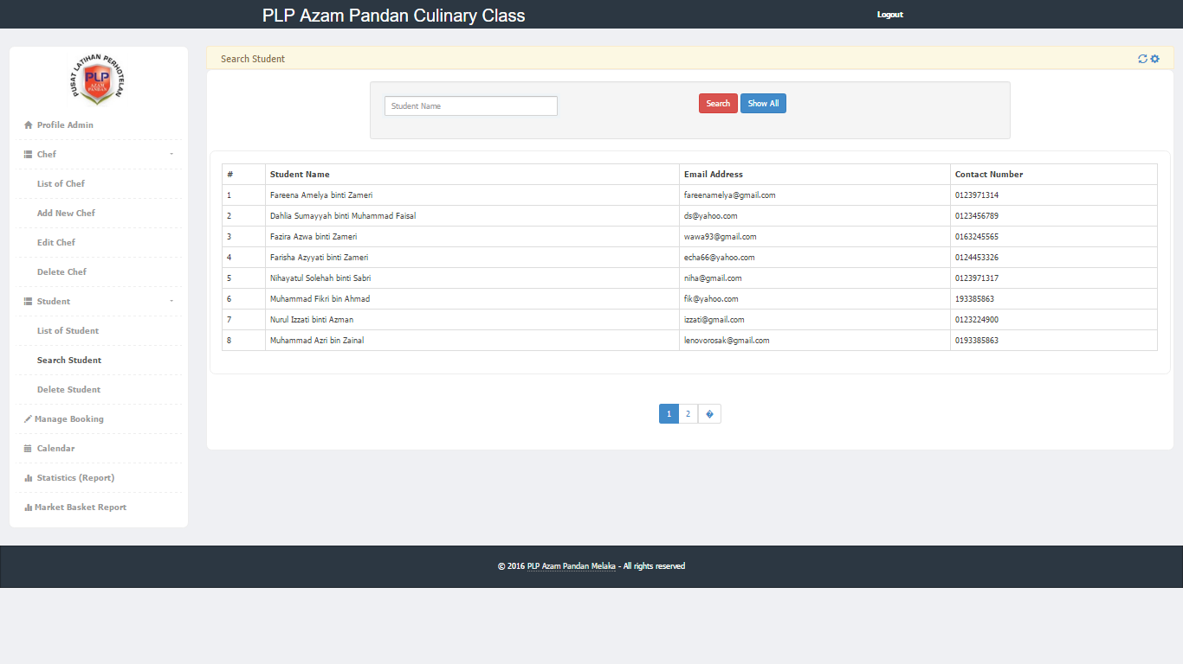

**Figure 4.11** Search Student Interface

Figure 4.12 below shows the interface for staff to delete the students in database. If the delete button was clicked, a pop out will displays and prompting to commit with the action.

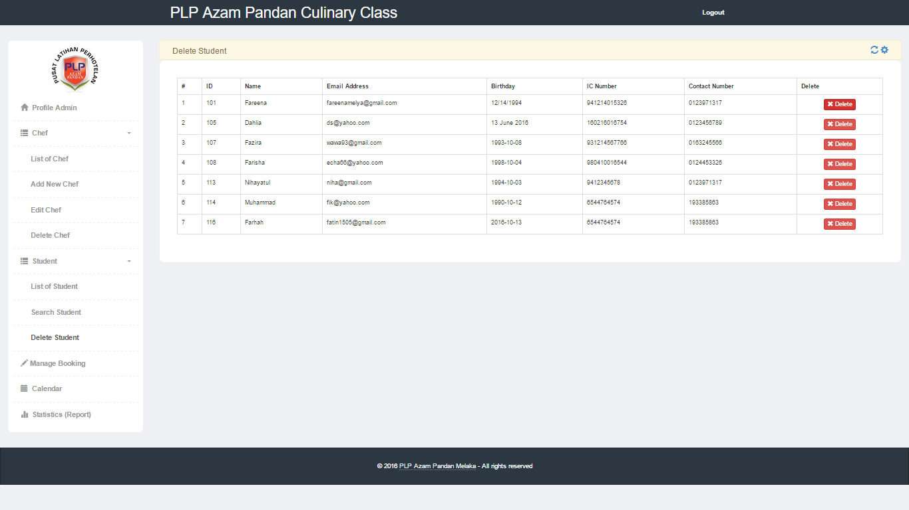

**Figure 4.12** Delete Student Interface

**4.1.6 Timetable Management Interface**

Figure 4.13 below shows the calendar for staff to insert, update, view and delete the culinary class.

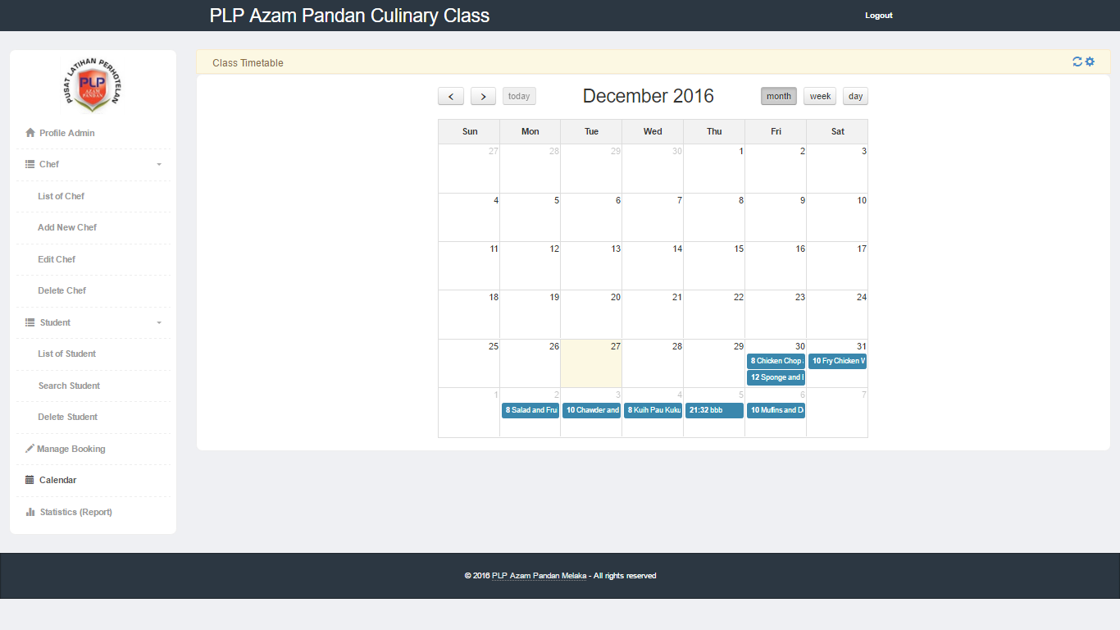

**Figure 4.13** Class Calendar Interface

Figure 4.14 shows the interface if the staff want to insert a new class in system. The staff required to input the details of the class such as class name, class category, time, instructor, location and fees of the class.

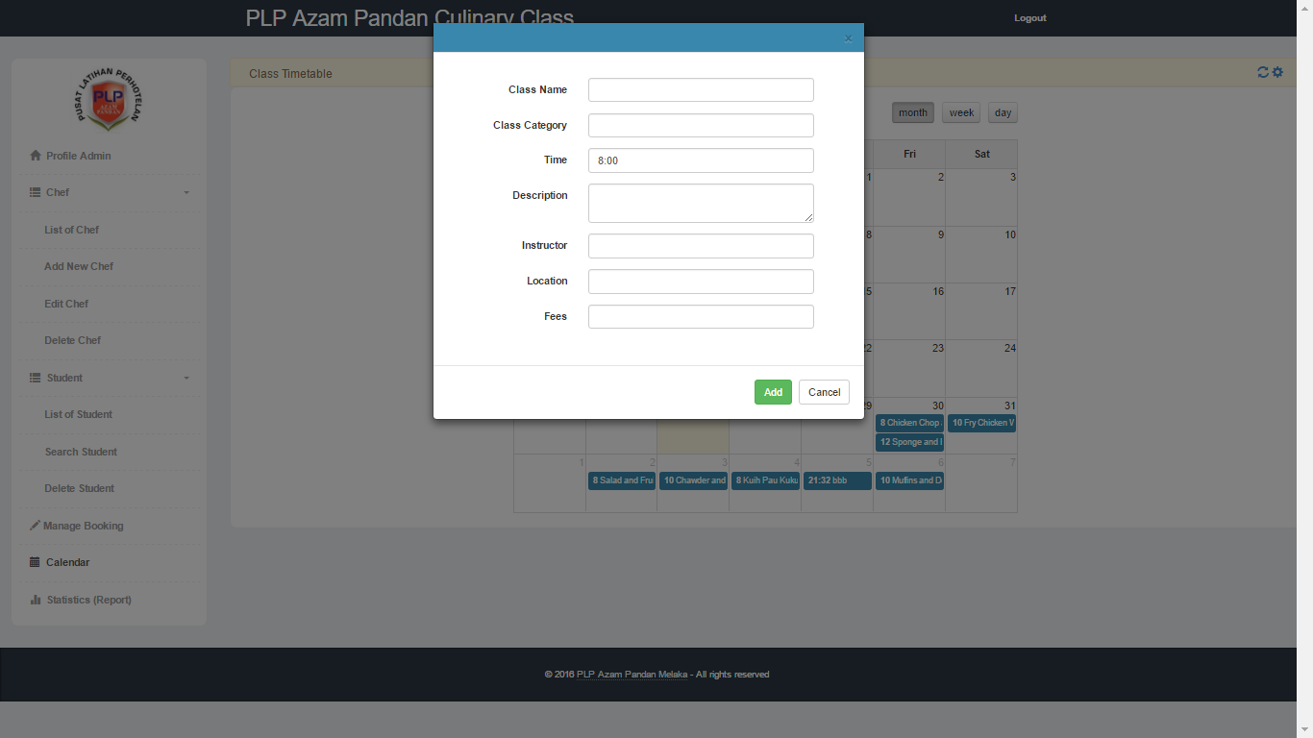

**Figure 4.14** Insert Class Interface

If the staff want to view the class details, they just have to click specific date and the details will be prompt out as shown in Figure 4.15. They can edit the details by clicking update button or delete the class by clicking delete button.

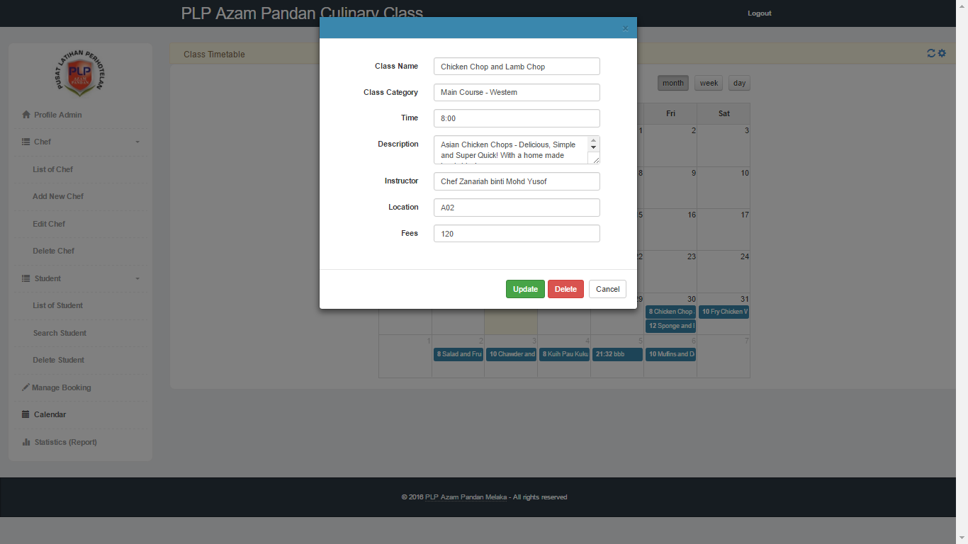

**Figure 4.15** View, Update and Delete Class Interface

**4.1.7 Booking Management Interface**

Figure 4.16 below shows the interface for staff to manage the booking class. Staff can view the list of student that booked specific class, the time and date of the booking, total fees and the status of the booking. Other than that, staff also can update the booking status of each student.

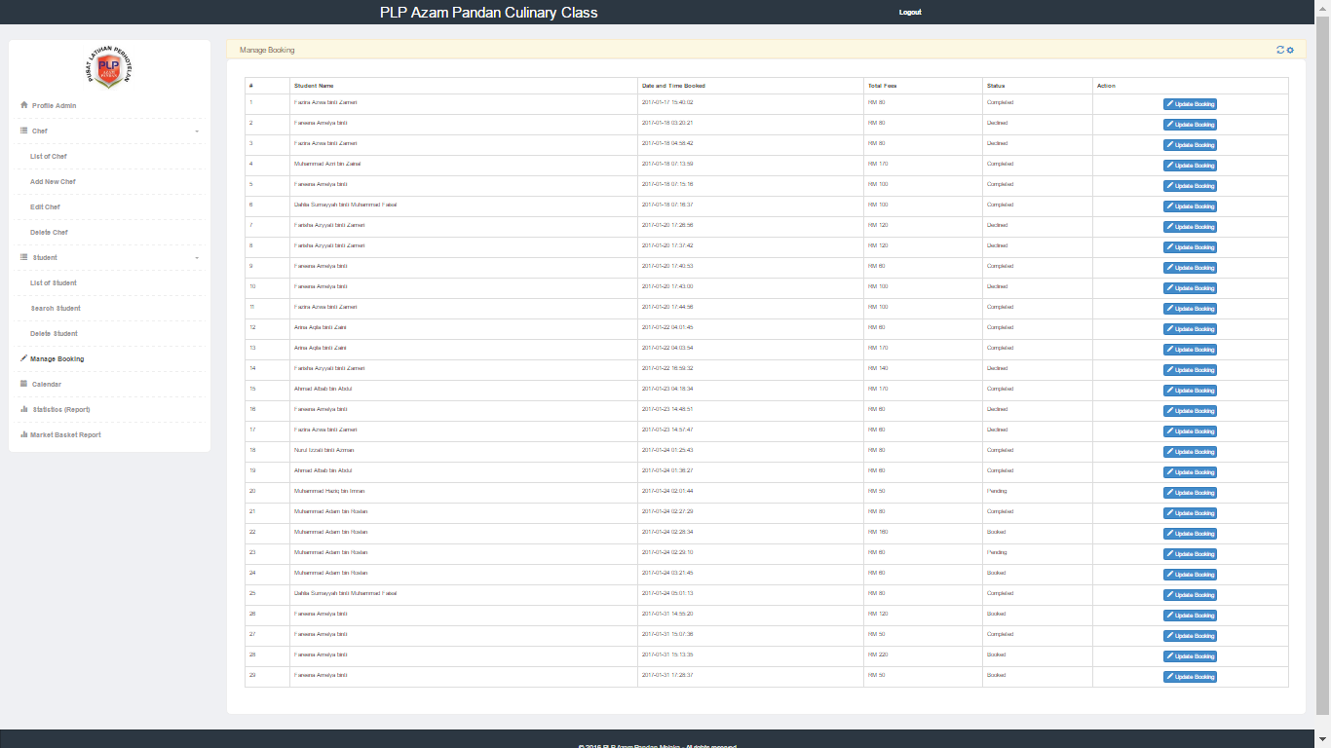

**Figure 4.16** Manage Booking Interface

If the staff clicked the update booking button, the page will be shown as Figure 4.17 below. The staff can check the receipt if it is fake or not. After that, staff can update the status of booking whether it is pending, completed or declined.

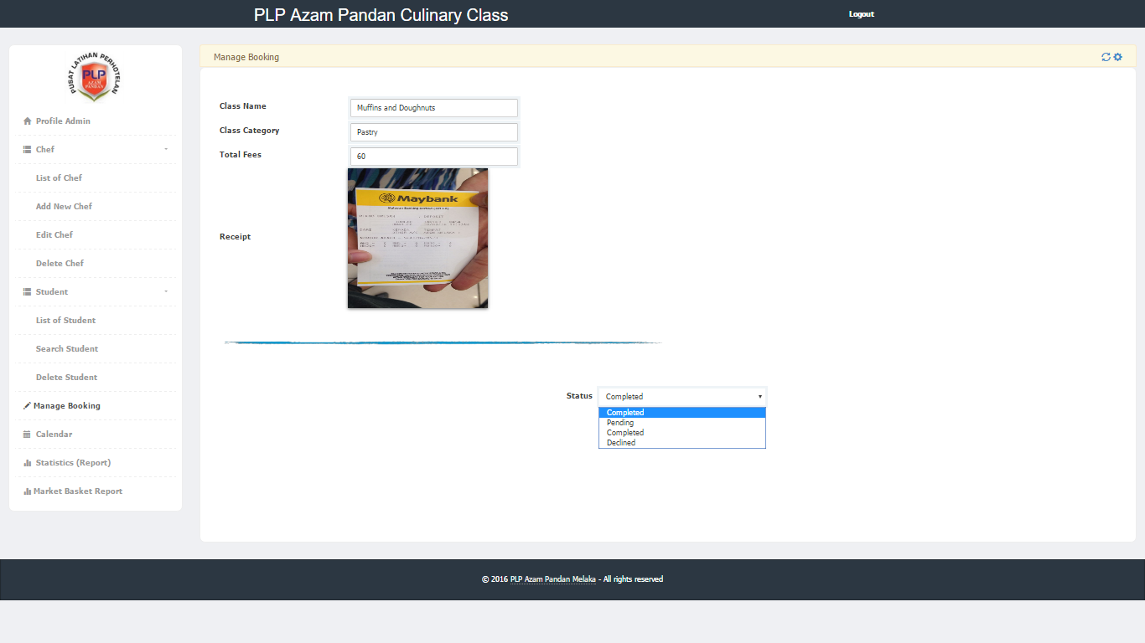

**Figure 4.17** Update Booking Status Interface

**4.1.8 Report Management Interface**

Figure 4.18 below shows the generated report that contains the class that has been booked by students. The report is showing a statistic of student in each class in a form of bar chart.

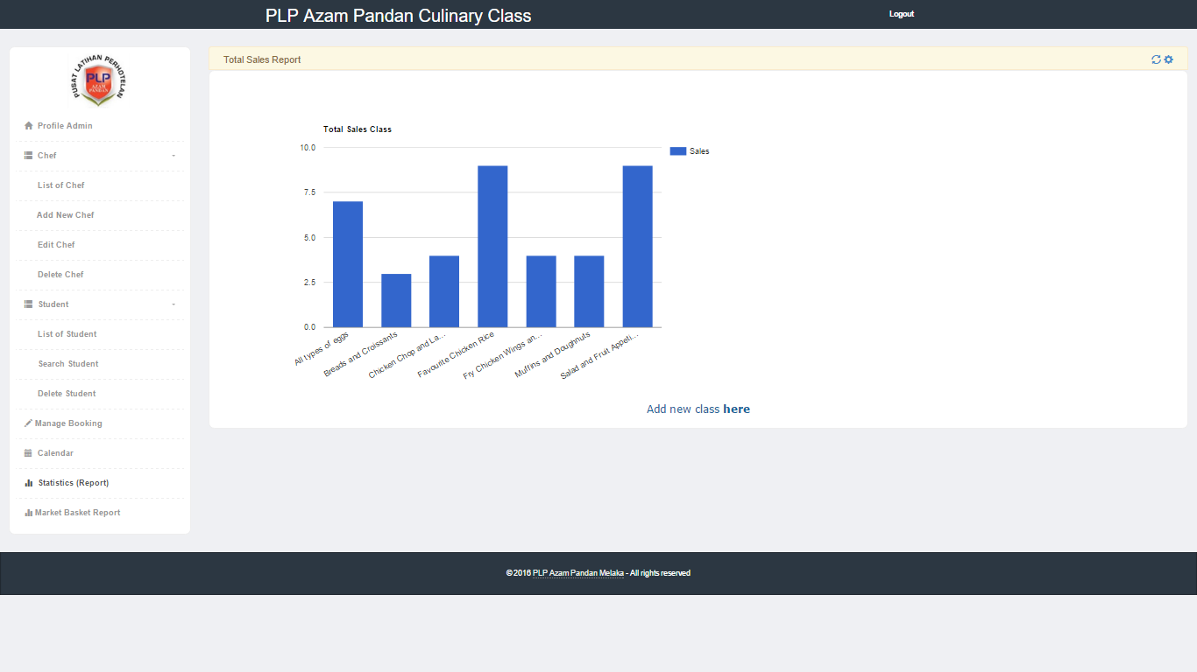

**Figure 4.18** Report Interface

Figure 4.19 below shows the report of class that have been booked by all students. The bar chart which is the first one illustrated the frequencies or support and is using the formula $support A ∩ B=\frac{amount of transaction A \& B}{total transaction}$ while the second pie chart illustrated the percentage of sale of each particular class. The table below contains the summary of every class such as relative frequency, book unit and total sales of each particular class. If we click the details in the page, it will shows a bar chart and table for calculated support of those class with other class, as shown in Figure 4.20.

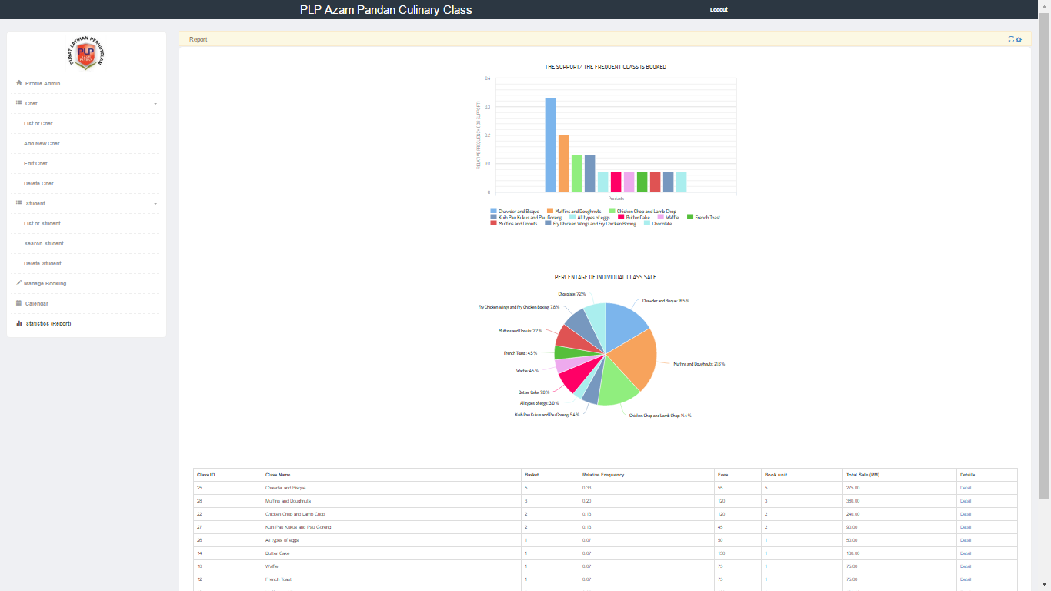

**Figure 4.19** Market Basket Report Interface

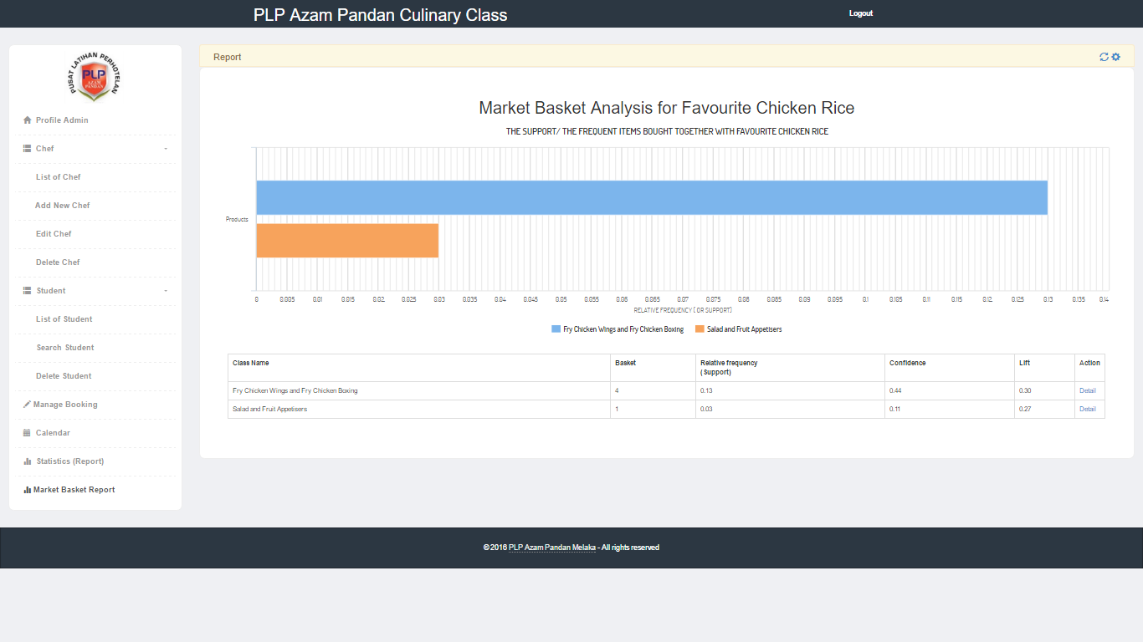

**Figure 4.20** Market Basket Analysis for Individual Class Interface

**4.2 Background Process**

In this section, all the background process such as connection to database, email form, PayPal Sandbox and Market Basket Analysis (MBA) will be explained in detailed.

**4.2.1 Connection to Database**

The database used in Pusat Latihan Perhotelan (PLP) Azam Pandan, Melaka Culinary Class Management System is MySQL database. Initial configuration needed to be able to access the database that have created as shown in Figure 4.21 below. The configuration contains information necessary to connect to the database such as the hostname, username, password, and name of database.

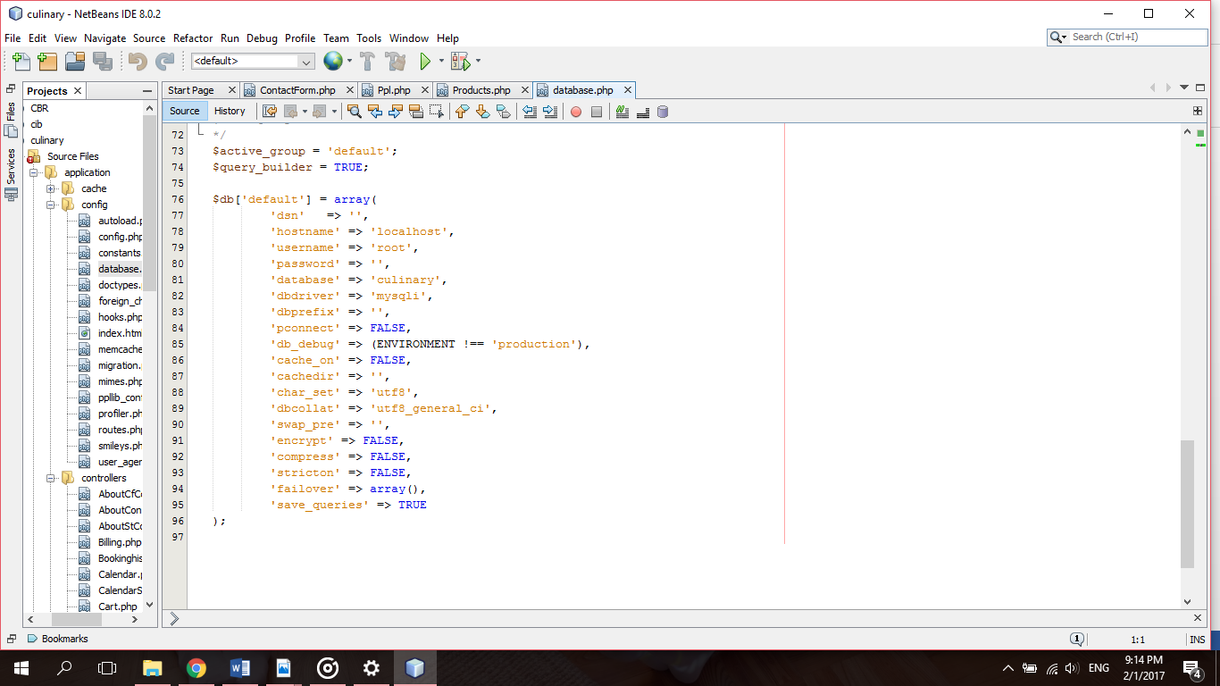

**Figure 4.21** Configuration Database Coding

**4.2.2 Contact Form Email Process**

Figure 4.22 below shows the interface of contact form of this web based system. Contact forms are a necessary part of websites as they are a means of communication between the user and the company. It is the medium for user to ask the company for more enquiries and details. The message will be send to the company by email. User are required to fill in the name, email address, subject and their message in the form.

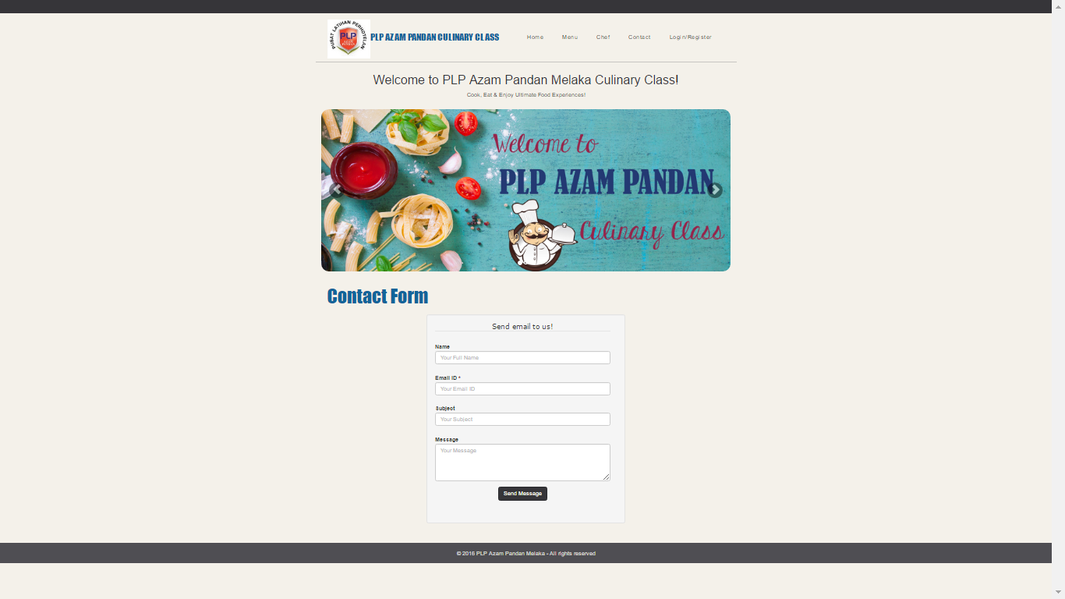

**Figure 4.22** Contact Form Email Interface

The email preferences need to be set and the email library is initialized to send email as shown in Figure 4.23 below. The email setting is set to Gmail smtp server port 465. Port 465 is used to sending email.

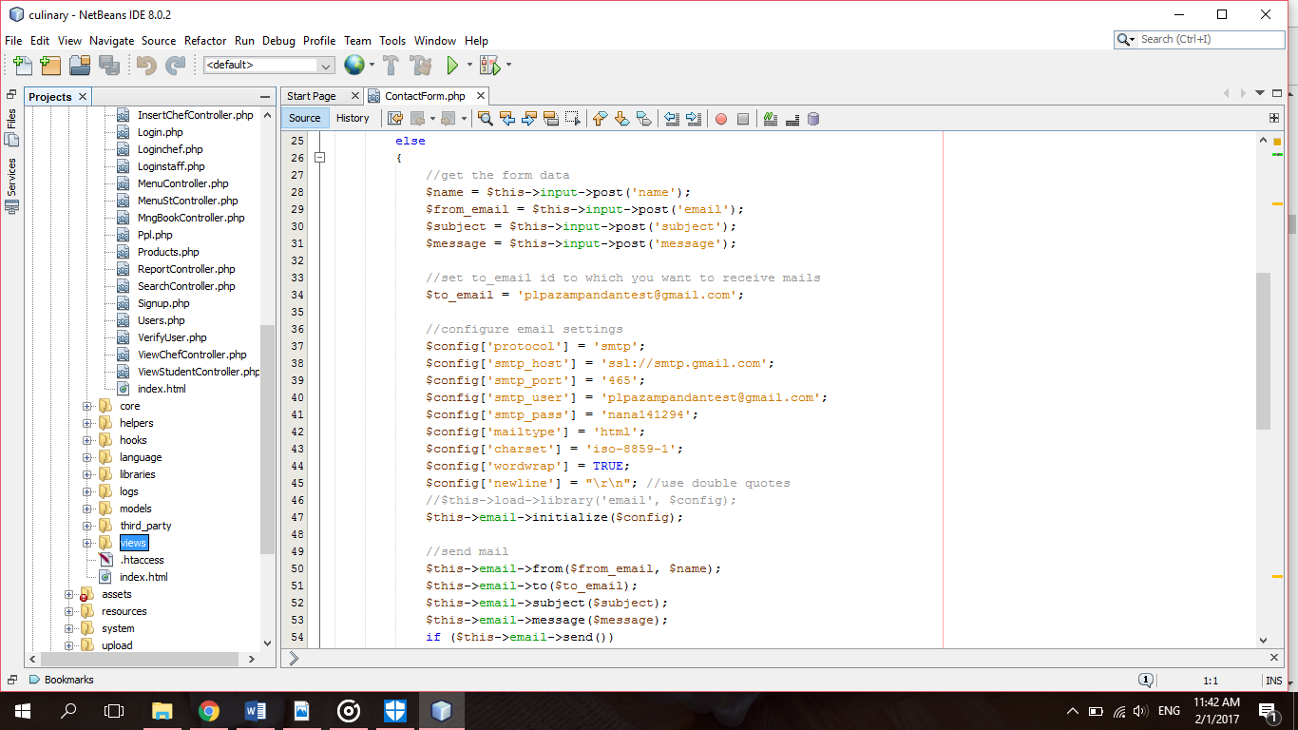

**Figure 4.23** Configure Email Coding

**4.2.3 PayPal Sandbox Process**

PayPal is the most popular payment gateway to send and receive payment worldwide. It is a widely used payment gateway to accept payment in the web application. The Sandbox account is created for testing a PayPal transaction. There are two accounts created which are buyer for personal purpose and seller for merchant or business purpose as shown in Figure 4.24 below.

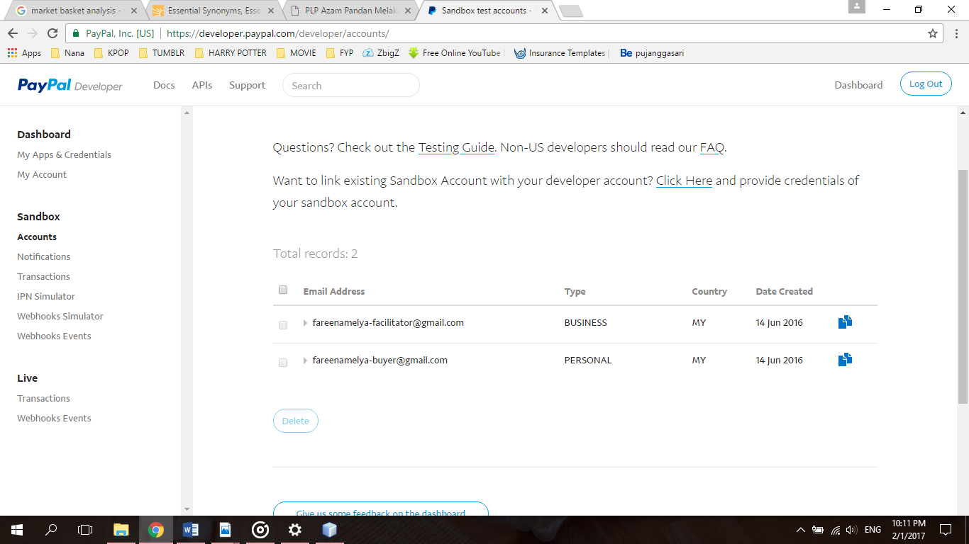

**Figure 4.24** PayPal Sandbox Business and Personal Account

Figure 4.25 below shows the coding for function buy(). It helps to generate the PayPal form and redirect buyer to the PayPal site once the checkout with Paypal button is clicked.

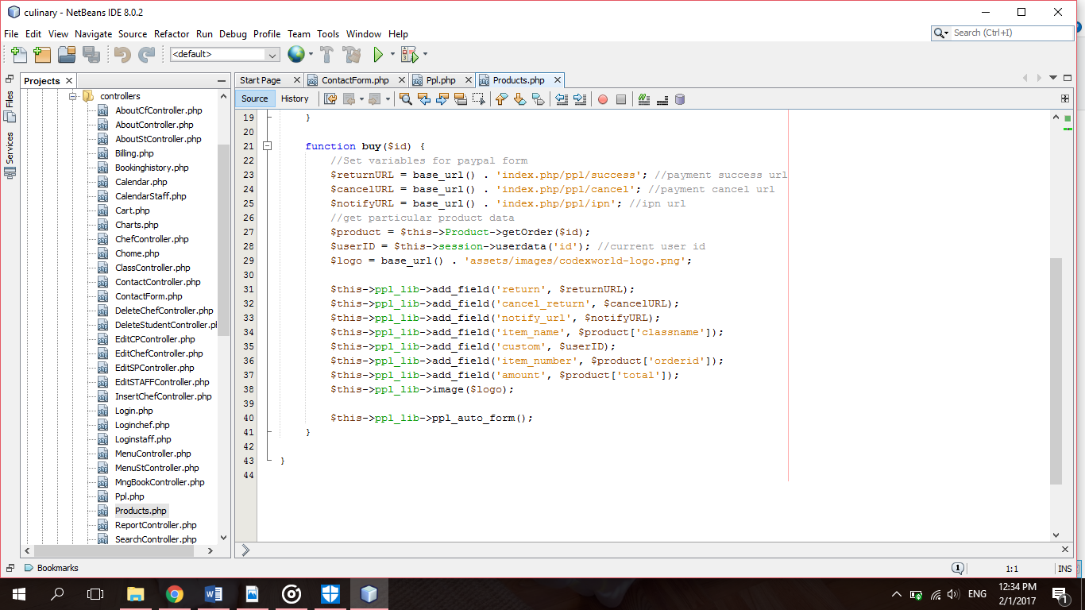

**Figure 4.25** PayPal Sandbox function buy() Coding

Figure 4.26 below shows the coding for function success() and function cancel(). The success() function is responsible for displaying the transaction data on payment success while the cancel() function is requested on payment cancel by the buyer.

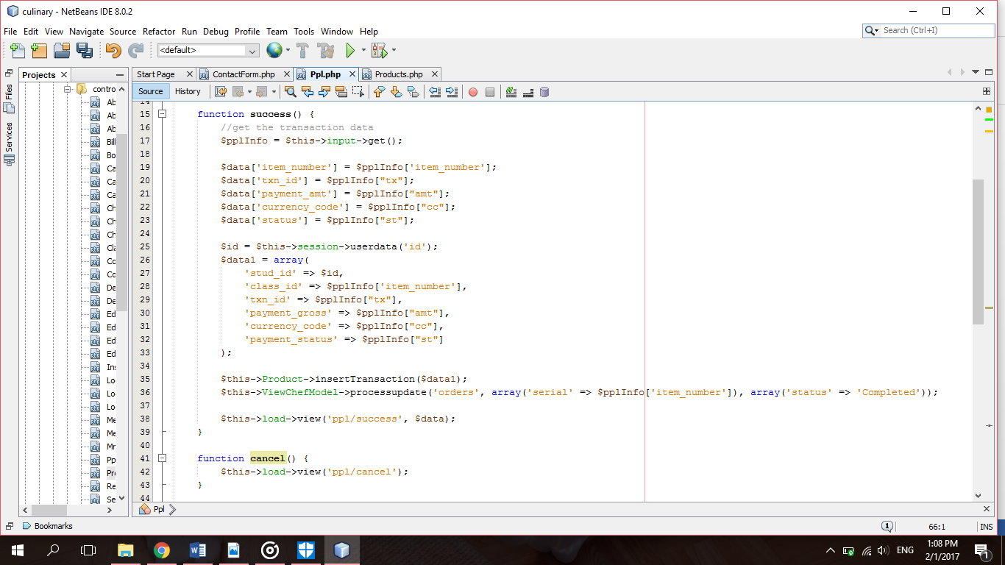

**Figure 4.26** PayPal Sandbox function success() and function cancel() Coding

The function ipn() as shown in Figure 4.27 below gets the transaction data by PayPal IPN and insert the transaction data into the database.

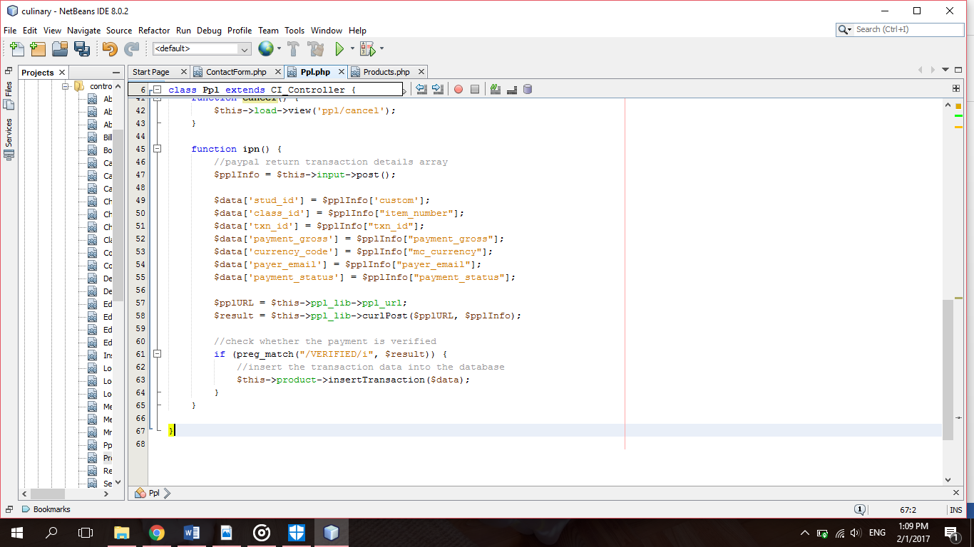

**Figure 4.27** PayPal Sandbox function ipn() Coding

**4.2.4 Market Basket Analysis Process**

Market Basket Analysis (MBA) will be used to generate a report for staff in Figure 4.28 below shows the query of Market Basket Analysis (MBA) to retrieve the number of frequency of class that is booked together. The function of the query is to identify the amount of transaction A & B based on the formula $support A ∩ B=\frac{amount of transaction A \& B}{total transaction}$.

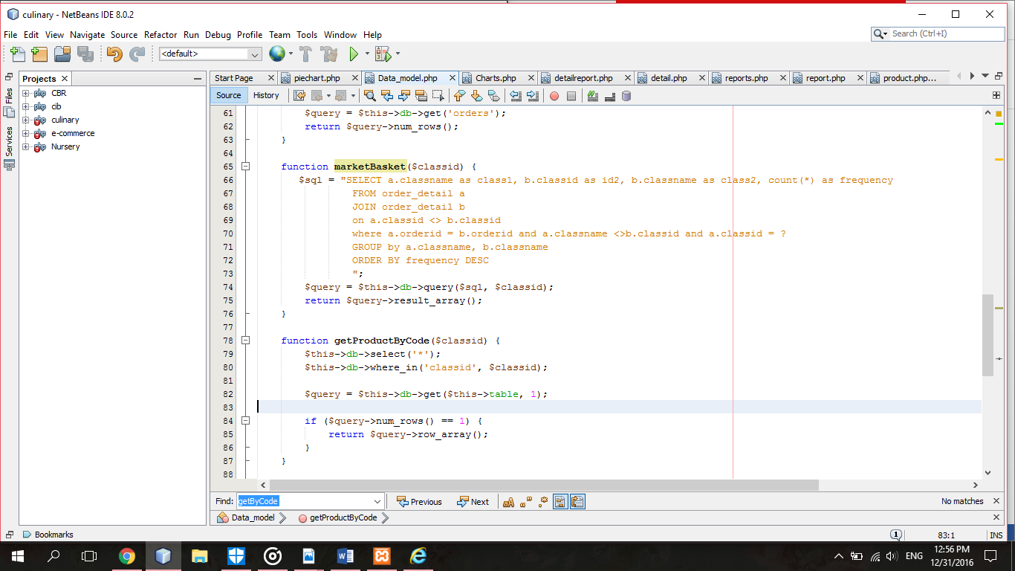

**Figure 4.28** Market Basket Analysis Query

**4.3 Functionality Testing**

Pusat Latihan Perhotelan (PLP) Azam Pandan Culinary Class Management System was tested using functionality testing to ensure that it has all the required functionality that's specified within its functional requirements. This testing has been conducted during testing phase by Madam Nurul Hidayah binti Ahmad Zukri, one of the lecturer from Faculty of Science Computer and Mathematics (FSKM). She is also my supervisor for this Final Year Project. The evaluated functional testing and her comments was recorded and posted on Appendix B. Table 4.1 below shows the list of modules for functionality testing of this web based system.

In conclusion, all the modules in the functionality testing produced its expected outcome. All users can successfully enter to the system if they enter a correct email and password. The data of student also is saving to database after they are registered. Next, student can successfully booked class from the list of class that is displayed in the web based system. Payment also can be done using PayPal or uploading a receipt of payment. The money in user’s PayPal account will be deducted after they made payment. Lastly, staff can view the generated report that is using Market Basket Analysis (MBA). Thus, this functionality testing was successfully evaluated in completing the development of Pusat Latihan Perhotelan (PLP) Azam Pandan Culinary Class Management System.

**Table 4.1** Functionality Testing

|  |  |  |  |  |
| --- | --- | --- | --- | --- |
| **No** | **Module** | **Expected Result** | **Actual Result** | PASS / FAIL |
| 1 | Login system | All users can enter to the system if they enter a correct email and password | All users can enter to the system if they enter a correct email and password | PASS |
| 2 | Register system | The details of student will save in database if they registered an account | The details of student will save in database if they registered an account | PASS |
| 3 | Send email | Anyone can ask anything about the culinary class in sending mail options | Anyone can ask anything about the culinary class in sending mail options | PASS |
| 4 | View Profile | All users can view their profile after they successfully enter the system | All users can view their profile after they successfully enter the system | PASS |
| 5 | Edit Profile | All users can edit their profile | All users can edit their profile | PASS |
| 6 | View Timetable | Student and Chef can view the class timetable | Student and Chef can view the class timetable | PASS |
| 7 | Book Class | Student can book class based on the timetable. | Student can book class based on the timetable. | PASS |
| 8 | Payment | Student can make an online payment using PayPal or uploading a resit if they paid using cash deposit machine. | Student can make an online payment using PayPal or uploading a resit if they paid using cash deposit machine. | PASS |
| 9 | View Booking History | Student can view their booking history | Student can view their booking history | PASS |
| 10 | View Chef | Staff can view all chef in system | Staff can view all chef in system | PASS |
| 11 | Add Chef | Staff can add new chef in system | Staff can add new chef in system | PASS |
| 12 | Edit Chef | Staff can edit chef profile in system | Staff can edit chef profile in system | PASS |
| 13 | Delete Chef | Staff can delete chef in system | Staff can delete chef in system | PASS |
| 14 | View Student | Staff can view all student registered in system | Staff can view all student registered in system | PASS |
| 15 | Search student | Staff can search student by enter the student name | Staff can search student by enter the student name | PASS |
| 16 | Delete student | Staff can delete student in system | Staff can delete student in system | PASS |
| 17 | Manage Booking | Staff can view the receipt and update the status of booking | Staff can view the receipt and update the status of booking | PASS |
| 16 | Timetable Management | Staff can view, edit, update and delete the class timetable. | Staff can view, edit, update and delete the class timetable. | PASS |
| 17 | Generate Report | Staff can view the generated report | Staff can view the generated report | PASS |
| 18 | Logout system | All users can logout from the system | All users can logout from the system | PASS |

**4.4 Summary**

The result of this functionality testing was important to determine whether Pusat Latihan Perhotelan (PLP) Azam Pandan Culinary Class Management System are able function and works appropriately. This purpose of the functionality testing is also to check if any problems or errors existing on the web based system.

**CHAPTER 5**

**CONCLUSION AND RECOMMENDATION**

This last chapter consists the conclusions and recommendations of the study. It was summarized and concluded what have been done throughout the project. Moreover, it also specify the potential future suggested in order to improve this project. The conclusion and features enhancement was divided for this section.

**5.1 Conclusion**

Pusat Latihan Perhotelan (PLP) Azam Pandan Culinary Class Management System was developed to improve the current process of the company business. So, this system aims to provide an online web based system that will help to manage the culinary class.

The main target user of this system is for the student, chef and staff of Pusat Latihan Perhotelan (PLP) Azam Pandan, Melaka. This project will help student to book and pay the class online. Other than that, this project will help the staff to manage all the chef and student of Pusat Latihan Perhotelan (PLP) Azam Pandan, Melaka by using a web based system. Staff also has the ability to view the report that are generated using Market Basket Analysis technique. By viewing the report, the staff will be able to see the customer booking preferences and can plan to give promotion by combining a class based on the analysis given.

In conclusion, the objectives of this project are fully achieved and the whole phases in methodology are successfully finished. Thus, this study was accomplished in completing the development of Pusat Latihan Perhotelan (PLP) Azam Pandan Culinary Class Management System.

**5.2 Limitation**

After the evaluation of Pusat Latihan Perhotelan (PLP) Azam Pandan Culinary Class Management System through the functionality testing, this web based system has some limitation which is the student who want to book the class has to be registered first.

**5.3 Recommendations**

This web based system was able to give satisfaction to the end user but there are still some opportunity to add more features to this system for improvement.

For future recommendation, Pusat Latihan Perhotelan (PLP) Azam Pandan Culinary Class Management System will improve by making every user able to book the class without registering an account. This web based system also will provide a credit card online payment for user that want to pay using a credit card.

**REFERENCES**

Abdul Aziz, N. F., Yahya, Y., & Mukhtar, M. (2011). Short messaging system (SMS) framework development: A case study of catfish industry in malaysia. *Proceedings of the 2011 International Conference on Electrical Engineering and Informatics, ICEEI 2011*, (July).

Artinah Zainal, Ahmad Nizan, & Kassim, Mohd Nizam. (2008). Malaysia Gastronomy Routes for Tourist Destinations. *Gastronomic Tourism Conference*, 8.

Grosan, C., Abraham, A. (2011). Intelligent Systems : A Modern Approach. Retrieved from <https://books.google.com.my/books?id=c1fzgQj5lhkC&lpg=PP1&pg=PP1#v=onepage&q&f=false>

Guadamuz, A. (2008). PayPal: The Legal Status of P2P Payment Systems, *20*(4), 1–14. Retrieved from <http://hdl.handle.net/1842/2262>

Gudla, S. K., Bose, J., Sunkara, S., & Verma, S. (2015). A Unified Push Notifications Service for Mobile Devices, 1–6.

Gupta, N., & Yadav, M. L. (2014). An Implementation and Analysis of DSR Using Market Basket Analysis to Improve the Sales of Business, 82–86.

He, Y., Shi, Y., & He, A. (2010). Research on online payment mode of E-commerce. *Proceedings 2010 IEEE International Conference on Software Engineering and Service Sciences, ICSESS 2010*, 312–315. <http://doi.org/10.1109/ICSESS.2010.5552440>

Holloway, D. L., & Anderson, A. (2009). Online Payment System for Merchants. (19) United States (12), *1*(19).

Kirkpatrick, M. (2009). System and Method for Electronic Mail Notification. UnIted States Patent.

Kotsiantis, S., Kanellopoulos, D. (2006). Association Rules Mining: A Recent Overview”, GESTS International Transactions on Computer Science and Engineering, Vol. 32, No. 1, pp. 71-82, January, 2006.

Kumar, A., & Jobari, S. (2015). Push Notification as a Business Enhancement Technique for E-commerce, 450–454.

Lewis, J. E. (2007). Electronic Mail Notification. (12) UnIted States Patent, *2*(12).

Liu, B. (1998). Integrating Classification and Association Rule Mining.

Mao, L., & Chen, S. (2015). The Growth of Mobile Payment and Effect on Consumption via Cash and Bankcard, (Bmei), 872–877.

Nengsih, W. (2015). A Comparative Study on Market Basket Analysis and Apriori Association Technique, 461–464.

Nor Fazliza, Yazrina, & Muriati. (2011). Short messaging system (SMS) framework development: A case study of catfish industry in malaysia. *Proceedings of the 2011 International Conference on Electrical Engineering and Informatics, ICEEI 2011*, (July). http://doi.org/10.1109/ICEEI.2011.6021576

Nosrati, M., Karimi, R., Makekian, K., & Hariri, M. (2013). PayPal as the Most Loved Payment System among Merchants and Buyers in Online Transactions. *World Applied Programming*, *3*(9), 396–400.

Pan, Z., Liang, X., Zhou, Y. C., Ge, Y., & Zhao, G. T. (2015). Intelligent {Push} {Notification} for {Converged} {Mobile} {Computing} and {Internet} of {Things}. *2015 {IEEE} {International} {Conference} on {Web} {Services} ({ICWS})*, 655–662. http://doi.org/10.1109/ICWS.2015.92

Skladman, J., Thornberry, R. J. (2009). Method and System for Selective Notification of E-mail Messages. UnIted States Patent.

Trnka, A. (2010). Market Basket Analysis with Data Mining Methods, 446–450.

Wang, Y. (2014). Mobile Payment Security , Threats , and Challenges.

Williams, D. (2007). *Pro PayPal E-Commerce*. Retrieved from https://books.google.com.my/books?id=KKqi2deBsg8C&lpg=PR2&dq=paypal&lr&pg=PR2#v=onepage&q&f=false

Xiao, H., Christianson, B., & Zhang, Y. (2008). A purchase protocol with live cardholder authentication for online credit card payment. Proceedings - The 4th International Symposium on Information Assurance and Security, IAS 2008, 15–20. http://doi.org/10.1109/IAS.2008.44

Yan, W. N. Y., & Chiu, D. K. W. (2007). Enhancing E-commerce processes with alerts and web services: A case study on online credit card payment notification. *Proceedings of the Sixth International Conference on Machine Learning and Cybernetics, ICMLC 2007*, *7*(August), 3831–3837. http://doi.org/10.1109/ICMLC.2007.4370814

Yang, Q., Cheng, Z., & Song, P. (2007). Research on Online Payment Mode Based On Internet Banking Payment Gateway. *2007 International Conference on Convergence Information Technology (ICCIT 2007)*, 2043–2048. http://doi.org/10.1109/ICCIT.2007.122

Zakaria, M., Wahab, S., & Jasmi, M. (2010). Culinary art education: A demanding profession in culinary tourism for Malaysian’s New Economy Niche. *Proceeding of the 1st UPI*. Retrieved from http://fptk.upi.edu/tvet-conference/download/TVET Conference Proceedings/Papers_Theme4/34_Mohd_Amin_Zakaria.pdf

APPENDIX A: INTERVIEW QUESTIONS

1. How many chef are working in PLP Skill Institute, Melaka?

Currently, there are 6 chefs working in PLP Skill Institute, Melaka.

1. Is all of the chef is divided by their specialty?

Yes. Each chef has different specialty and is assigned to different type of menu.

1. How many types of menu offered in PLP Skill Institute, Melaka?

There are 11 types category of menu which are Local Breakfast, Main Course – Local, Farinacious Products – Local, Western Breakfast, Produce Soup, Produce Appetizers, Produce Sauce and Dressing, Produce Desserts, Main Course – Western, Snacks and Cocktail dishes and Pastry / Bakery Products.

1. How the timetable of class is arranged?

The timetable is arranged based on the package of menu offered. The staff just generate the timetable manually.

1. Does the timetable is fixed?

No. The timetable will changed and will be arranged back by the staff based on a class that are on high demand.

1. Does the chef determine his/her own class?

Each chef will be given a weekly timetable with the location of class for practical training.

1. Does the staff has their report for the class that is on high demand?

No, the staff doesn’t have the class report.

1. What is the process of registration for a new student?

The student can register by downloading the registration form in the website by choosing the package of menu offered in PLP Skill Institute, Melaka. The student must register at least 2 weeks before the class started.

1. What is the current method of payment for student to pay their fees?

Payment can be made by come to our office at least one week before the class begin.

1. Who is handling the student registration before?

The student registration is handle by our admin or Chief Coordinator of program, Cik Nor Diyana binti Abd Rahman.

1. How the student profile is stored?

The student form is stored in file system.

1. How many students per class?

Every package of menu is assigned for 10-15 students only.

APPENDIX B: FUNCTIONALITY TESTING FORM



